East Valley School Mass Casualty Significant Event Readiness Forum (SERF) Executive Summary

The East Valley School Mass Casualty Significant Event Readiness Forum (SERF) was held was held on April 14, 2026, from 8AM to 3:00PM. The event location was the Desert Willow Conference Center (4340 E Cotton Center Blvd, Phoenix, AZ 85040). A total of 88 people attended the SERF. The attendance by industry is displayed on the third page.

There were seven objectives that guided the event. By the end of the event, participants were to have a better understanding of:
- Unified Command (including roles and responsibilities of schools).
- Roles and responsibilities of fire, law enforcement, and hospitals during an incident involving students/staff (including tribal as well as special needs students).
- Municipal/other support for student/staff evacuations of school buses when no additional school bus drivers are available.
- Hospital Emergency Department surge support needed with an influx of injured students, including special needs students and staff with respiratory issues and severe burns.
- School, hospital, and other communications with parents, patients, and others (including the role of Public Information Officers and the Joint Information Center).
- Coordination of hospitals during a Mass Casualty Incident.
- School reunification and how this is connected to municipal family reception centers.
Evaluations conducted during the event showed improvements on all objectives as a result of the event.

Two scenarios were used to foster discussion among the participants:

First Scenario: It is a Saturday afternoon in early September. Ten school districts are traveling by bus to a regional marching band tournament hosted at a large East Valley high school. Five districts are local while the other Five are from outside the valley. There are 50 school buses with 20 school trucks hauling trailers on route (2,400 band members, color guard, and other students and staff, including students and adults with access and functional needs). Routes planned are SR-60 (15 drivers), Loop 202 (20 drivers), and surface streets through Mesa and Chandler (15 drivers).

The tournament is scheduled for 5:00PM with arrival times of school vehicles at approximately 2:30PM. The National Weather Service forecast for the morning mentioned possible isolated dust storms, but conditions appeared stable at the time of departure.

During transport, a large dust storm approaches rapidly from the southeast. Drivers are reporting sudden and extreme gusts of winds, visibility reductions, and brown skies in the southeast. Communications are abruptly disrupted among the drivers as collisions occur.

Power outages and downed power lines are reported on Loop 202, causing additional traffic collisions at intersections. Emergency response is overwhelmed. Fire, EMS, and law enforcement units are stretched across multiple simultaneous mass-casualty scenes, while hospitals experience rapid Emergency Department surge dominated by pediatric patients. Communications are strained as parents flood schools, hospitals, and 911 centers seeking information. School districts must coordinate student accountability, bus evacuations without available drivers, and reunification planning, while municipalities activate family reception centers and Joint Information Systems. The incident requires Unified Command, regional hospital coordination, public health involvement for respiratory impacts, and sustained multi-agency operations under deteriorating weather conditions.

Initial estimates are more than 200 vehicles impacted with thousands of drivers and passengers, many of whom are students and children.

Second Scenario: During a late-afternoon monsoon thunderstorm in the Phoenix East Valley, a rapidly advancing haboob develops along the storm’s outflow boundary. According to National Weather Service the dust wall reaches several thousand feet high and moves at highway speeds, producing near-zero visibility within minutes. Visibility along major corridors in the east valley, including the I-10, Loop 101, and key arterial roadways, drops to less than 50 feet. Strong outflow and microburst winds exceeding 60-70 mph accompany the dust storm, pushing vehicles off roadways, overturning high-profile vehicles, and causing sudden, multi-vehicle pileups.

At the time of impact, school buses are actively transporting students home and to after-school activities across multiple districts, including the Chandler Unified and Kyrene School Districts. More than 210 school buses (including those for special education students) become involved in crashes due to chain-reaction collisions and loss of visibility. One bus is struck broadside and ignites, resulting in burn injuries and smoke inhalation among students and staff. Another bus is forced off the roadway into a nearby canal, partially submerged with students trapped inside. Other buses are disabled in traffic lanes with injured children unable to self-evacuate. Injuries range from minor to severe, including fractures, crush injuries, burns, respiratory distress, and pediatric trauma complicated by special medical and access and functional needs.

Emergency response is immediately overwhelmed. Fire, EMS, and law enforcement units are stretched across multiple simultaneous mass-casualty scenes, while hospitals experience rapid Emergency Department surge dominated by pediatric patients. Air medical transport is grounded due to visibility and wind conditions. Communications are strained as parents flood schools, hospitals, and 911 centers seeking information. School districts must coordinate student accountability, bus evacuations without available drivers, and reunification planning, while municipalities activate family reception centers and Joint Information Systems. The incident requires Unified Command, regional hospital coordination, public health involvement for respiratory impacts, and sustained multi-agency operations under deteriorating weather conditions.

Initial estimates are more than 200 vehicles impacted with thousands of drivers and passengers, many of whom are students and children.
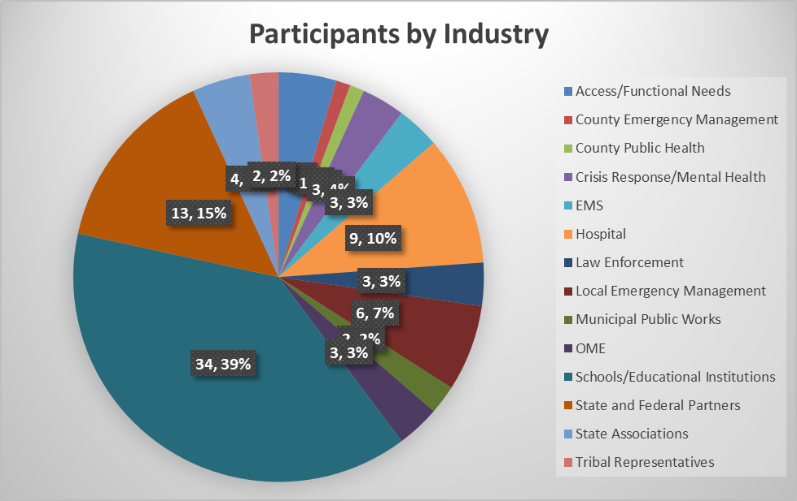

There were fifteen considerations resulting from the event:
- Depending upon the weather conditions and forecast, use all available municipal and hospital drones as well as the Arizona Department of Transportation cameras to assess the scene and available pathways for first responders to safely reach victims (including first responders impacted by the incident). Municipal Public Works Departments also have camera centers, which may prove invaluable.
- Explore how Unified Command can ensure interoperable communications. Remember to integrate Tribal Nations in communications capacities.
- Invest in tents external to the hospitals. The Metropolitan Medical Response System Base-X tents are 20 years old, dependent upon municipal staff for erecting (unless military resources are activated), and take an extended time to assemble. While there may be additional weather issues, the tents will offer additional space to accommodate patients given the potential inability for air ambulance services to transport patients to other regions of the state.
Alternatively, designate other areas of the hospital to manage the surge (Las Vegas designated specific areas for designated specialties, such as orthopedics). While the hospitals will decompress to standards, the scenario does not indicate numbers representing all of the individuals who will impacted by respiratory issues, which would increase the surge. Work with Sky Harbor Airport, Uber, Waymo, Lyft, Chambers of Commerce, Visitors Bureaus (able to access resorts, hotels, and motels), and other businesses to deter additional vehicles being added to the situation. Consider municipal and tribal Business Operations Center integration so mutually-beneficial relationships are established prior to an incident. Remember that the hospitals may need resources – such as food and beverages – to support the patient loads.
- Send one school representative to each hospital to assist with communications with the schools/district, victim identification, and patient medical needs using “master lists’ or rosters of those assumed to be involved in the incident (clarifications of those who were actually impacted versus those who were not may occur between the school representative at the hospitals and the school Emergency Operations Center [EOC] staff). Make sure Individual Action Plans are available for each known student being transported and to assure tracking and return of durable medical equipment for special needs/access and functional needs students.. Establish relationships prior to an incident so instructions are clear for school representatives to reach hospital incident commands/Emergency Operations Centers.
- Reconfigure/modify the Mass Casualty Tracking and Reunification Arizona Collaborative (MCTRAC) to include local interests, such as schools. Change the name of MCTRAC as this confuses other counties in terms of the technology being applicable to the entire state of Arizona. While a platform has been created by the Arizona Department of Emergency and Military Affairs’ Division of Emergency Management (DEMA), all stakeholder buy-in has not been secured, including hospital concurrence on the HIPAA compliance.
Plan an East Valley and Phoenix mass casualty incident exercise to test the MCTRAC replacement in Maricopa County in 2026-2027. Routinely test systems to prevent memory decay by users.
Host a conference for all local, Tribal, and county emergency managers and public health, hospitals, fire, EMS, SILC/ADA compliance managers, crisis response teams/behavioral health, and local interests (to include schools) in 2026-2027 to customize applications of tools and flowcharts.
- While school districts involved in the SERF are establishing intergovernmental agreements for transportation in the region, explore additional capacities to communicate with schools/districts external to the region for communication pathways during an incident.
- Establish monthly/quarterly Joint Information Center communications with law enforcement and other relevant entities to provide continuity of messaging following an incident.
- Support the establishment of the Arizona School Safety Center to ensure School Safety Officer continuity in training. Within this group, investigate beneficial relationships/ agreements between schools and public transportation, such as Valley Metro (including arrangements for the continuum of disabled students.
- Since schools cannot send representatives to hospitals, local and Tribal EOCs, as well as the County EOCs, look into priorities and alternative, efficient modes of communications with the schools/districts.
- Prioritize Family Referral Centers for each Tribal Community and municipality since the Tribal leaders and municipal elected officials will hold their own communities accountable and gain the culturally competent attention required. As the Maricopa County Department of Emergency Management (MCDEM) is in the process of creating a template to address the issue, it merits only emphasizing that this guide is needed and appreciated. Make sure all planning integrates the access and functional needs community.
- While Crisis Response Teams are available in many communities in the Valley, municipal and Tribal emergency managers are encouraged to foster an increase in the program (as a result, more resources may be available to address a mass casualty incident) and include them in all exercises. Since Maricopa Association of Governments (MAG), manages the curriculum for the training, it is further requested that attention be given to prioritizing training on crisis response for children and adolescents, which is gained through experience and the unique training of the municipalities at this point in time. Maricopa County Crisis Response Teams are unable to do this without elected official attention, with special attention to the Mayors. Local emergency managers may not have the ability to elevate the attention needed (it is believed that the Tribal Emergency Managers can do this).
- Adjust school district policies requiring an administrator or other school staff member to accompany each student to a hospital during an incident that requires these individuals to attend to other priorities. The tasks are overwhelming and impossible during a mass casualty incident. Be clear about the process of who will notify family/friends of the deceased as the Medical Examiner’s Office, doctors, and nurse practitioners must issue death certificates in Arizona (different circumstances apply).
- Since Valley Crisis Response Teams may need to be at the scenes and overwhelmed, explore work with the Arizona Psychiatric Society, Arizona Psychological Association, Mercy Care, and other mental/behavioral health associations (a number of which have disaster committees). These are force multipliers that may not be needed on a normal “day,” but could be valuable during a mass casualty incident.
- The Arizona Craig Tiger Act requires a specific type of mental health services for first responders. Since BORR is already working on the topic, it is suggested an advisory committee be convened with the relevant associations.
As soon as the event was completed, work began on revising the old MCTRAC flowchart, envisioning a new patient tracking device for Arizona to be vetted by hospital and system leaders, creating a planning team to guide initial plans and exercises, renaming MCTRAC so other counties in Arizona would not perceive the project as a Maricopa County-only effort, and determining a conference location to enable statewide customization of the project.

