Tri-State Shake & Bake Significant Event Readiness Forum (SERF) Executive Summary

The Tri-State Shake & Bake Significant Event Readiness Forum (SERF) was held on March 5, 2026, from 8AM to 3:00PM. The event location was the Optimum Center (2380 Optimum Way, Bullhead City, AZ). A total of 71 people attended the SERF. The attendance is displayed on the next page.

There were eight objectives that guided the event. By the end of the event, participants were to have a clearer understanding of:

- How threat/hazard information will be relayed.
- How infrastructure access and accessible transportation services will be provided.
- How critical infrastructure functions will be stabilized.
- How lifesaving medical treatment will be provided.
- How communications will be provided.
- How mass care services will be provided.
- How minimally affected communities interact and help with response efforts.
- How local, state, tribal, and federal agencies work together under a Unified Command.

Participation information is listed in the chart below.

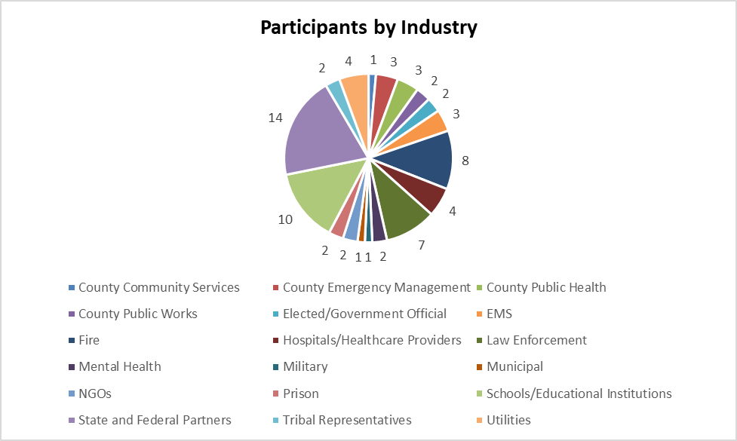

Evaluations conducted during the event showed improvements on all objectives as a result of the event.

Four scenarios were used to foster discussion among the participants:

First Scenario: A 6.7 magnitude earthquake occurs at 8:57AM with an epicenter in the Topock area near the Topock Crossing (I-40 at the Colorado River). The quake is felt across Mohave County with reports of strong shaking in Topock, Bullhead City, Lake Havasu City, Golden Shores, Fort Mohave, and Mohave Valley.

Shortly after the shaking subsides, reports come in of structural damage to roads and bridges, widespread power outages throughout Mohave County, and damage to homes and commercial buildings along the Colorado River Communities. Most critically, preliminary assessments from the Bureau of Reclamation and local dam operators indicate compromised integrity within the Davis Dam levee system. Though full dam failure is not confirmed, the dam is operating under emergency protocol. At the time of the earthquake, the Fort Mohave Indian Tribe is hosting a large intertribal conference at the Avi Resort and Casino, located along the Colorado River, just south of the impact area. The event has drawn numerous tribal leaders, emergency response personnel, and community members from multiple tribal nations to include all of Mohave County tribes.

Due to the locations proximity to the epicenter and the potential downstream risk from Davis Dam, concerns arise regarding both the structural safety of the facility and the immediate need for coordinated evacuation planning and communications between tribal and county response partners.

Emergency phone systems are being inundated with calls from the public trying to find out information, reporting damage, reporting injuries, and asking for help.

Second Scenario: Roughly 60 minutes after the 6.7 magnitude earthquake near Topock, preliminary assessments begin rolling in from across the county. In Bullhead City, widespread panic has resulted in many residents self-evacuating before official guidance is issued. Dispatch services throughout the county are overwhelmed with calls from residents reporting structural damage, gas leads, impassable roads, multiple vehicle crashes, and a need for medical help throughout the affected area. The traffic lights remain inoperable due to the power outage, and congestion continues to worsen on Highway 95 near Community Park and major intersections. The Avi Resort & Casino reports sustained interior cracking, structural compromise, some report of structural failure, unknown injuries. Partial evacuation is underway. All first responder services are being stretched beyond their limits.

There are reports of people being self-transported to hospitals in Mohave Valley, Bullhead City, and to a lesser extent, Lake Havasu and Kingman. There have been reports of some structural damage to the hospitals in Mohave Valley and Bullhead City; however this has not been confirmed. There are unconfirmed reports of many more injuries and potential deaths within the affected impact zone. Reports are still filtering in.

Schools are currently in session and there are reports of potential injuries to students and staff, in addition to some structural damage to the schools. Parents are reportedly showing up at the school.

In Lake Havasu City, several commercial buildings downtown have sustained structural damage. Havasu regional Medical Center is operating on backup power but is overwhelmed by the number of injured individuals arriving by private vehicle. Reports indicate that many resident and visitors are attempting to flee the area, causing backup at all major routes out of the city, including Highway 95 and SR-95 South toward Parker.

In Golden Shores and Topock, multiple residences have sustained heavy structural damage. Roads have become impassible due to ground shift, collapsed culverts, and landslides along narrow access routes.

A large debris field is identified on I-40 westbound near the Topock exit. The BNSF railroad bridge in the same area is partially collapsed.

Though Parker and Hoover Dam structures are currently stable, concerns about water flow and sediment contamination are rising. Evidence of subsidence at Davis Dam, and earthen embankment dam, has triggered a Level 2 notification to downstream communities. Early reports suggest that liquefaction is confirmed in saturated soils along the Colorado River floodplain, affecting buried infrastructure.

Third Scenario: Roughly 3 hours after the earthquake, as damage assessments continue, cascading infrastructure failures begin to mount. Key utility (electric, gas, cellular services, internet, and water) outages persist across the county. In Kingman and Lake Havasu, potable water pressure is dropping due to power loss at multiple pump stations and damage to underground lines. Multiple neighborhoods in Bullhead City and Mohave Valley are reporting little to no water availability.

Natural gas lines are confirmed ruptured in several areas, including residential neighborhoods in Bullhead City and near downtown Kingman. As a result, some gas lines have been shut off to prevent fires and explosions. In some communities, this leaves residents unable to cook, heat water, or operate generators.

ADOT has closed the I-40 bridge and the Topock Crossing due to structural damage to the bridge. It has been determined that all bridges in the immediate affected area will need to be closed until they can be inspected by the road crews and/or structural engineers. The railroad has also stopped all rail traffic within the county until bridges can be inspected in the affected area, to include the rail line that crosses the Colorado River at the Topock Crossing.

As emergency generators run low, fuel access is now a critical issue. Local gas stations are unable to pump fuel due to sustained power outages. Emergency responders – particularly law enforcement – report critical fuel shortages.

Public anxiety continues to grow. Rumors of dam failure, radiation leaks, and government coverups are spreading on social media. Several shelters report being overwhelmed, including those in Fort Mohave and Lake Havasu. Public health and public information teams struggle to counter misinformation while maintaining coordination.

Fourth Scenario: By mid-afternoon, roughly 5 hours after the initial earthquake, aftershock activity is slowing but still ongoing.

The Colorado River remains under a no-contact advisory from Bullhead City to south of Topock, pending full analysis by ADEQ. Recreational access is suspended. Animal carcasses, debris, and chemical residue are visible along the shoreline.

Colorado River Communities downstream from the Davis Dam are considering the impacts to their communities if there is a 50,000 CFS release from the dam as has been suggested.

Re-entry is complicated by public demand to return to damaged properties and resume normalcy. Evacuated areas remain unstable, particularly those near the riverbanks and hillsides where landslides are a risk. Some roadways remain impassible.

There were twenty-five considerations resulting from the event:
- Identify where to establish Incident Command and ensure all liaisons are included.
- Identify mutual aid partners and put written agreements in place. Establish priorities for the County mutual Aid Plan.
- Establish PIO groups across all entities. Within this arena, ensure communications are made from “the field” to decision-makers for information distribution to the communities. In addition, utilize resources established through volunteer services (communications with businesses).
- Identify to integrate the RAVE tool into communication plans.
- Look at all assets available for evacuation (how long until AMTRAK is assessed, are school buses available, what private sector transportation options are available, can aircraft be used as the airports are working, what help is available from Las Vegas … what IS working?).
- Revisit methods for moving patients (if buses were considered and are not available, how will patients be moved?). Can the Arizona Fire Chief’s Mutual Aid resources for ambulances outside of the region help?
- Understand how the Prison system may be able to assist (sand bags, medical staff, and more).
- Establish how those that rely on powered medical equipment will be identified and assisted during prolonged outages. In addition (pertaining to access and functional needs populations), what is being done to assist the long-term care facilities, such as nursing homes, to remain operational?
- Explore evacuation destinations (will hotels take evacuees? Do school and Family Reception Site/Family Assistance Centers, and fatality management storage sites need to move? Look at the Red Cross Mass Casualty Incident Report of 2015; the Red Cross would be the lead on shelters and locations).
- Explore including utility representatives on aircraft to assess damages.
- Ensure Emergency Operations Centers are located in safe buildings (may need to relocate; are do Continuity of Operations Plans [EOCs] need “hardening?) Linked to this, be sure elected officials understand the need to go to the EOCs and not to first responder locations (elected officials may take ICS 402 classes to understand their roles).
- Determine how to handle staffing shortages, as it relates to cascading events (look at CERTs and Team Rubicon).
- Use vehicles to communicate if radios/other communication methods are not working (look at CERT support); access Ham radio operators; and/or move to “old time” methods of using bullhorns to alert communities.
- Explore satellites, drones, fixed wing and other air assets for real-time monitoring.
- Establish methods for getting fuel to the hospitals from municipal/county fuel storage sites.
- Look at the use of military assets (all three Adjutant Generals of the states would be alerted to the incident). These may come at a cost, but the needs may supersede the costs.
- Identify how to effectively tap into private partnerships. Assess the resources available through the private sector (can truckers bring in supplies?).
- Identify resources that are available to be shared and ensure cross training for these resources.
- Identify which agencies and partners participate in AzMAC and ensure they know how to access resources they need.
- Identify who will respond to unincorporated cities and towns, particularly on or near the Tribal Lands to ensure that, despite limited resources, they are not left unattended
- Establish how schools will receive updated information as well as guidance during an emergency.
- Identify resources available for cascading events and the continued normal events, to include resource tracking to avoid committing resources that are already in use.
- Identify ways to address animal assistance beyond household pets, such as livestock.
- Read through the Craig-Tigers Act and ensure all first responders and others involved in managing the incident (including public health, hospital staff, and emergency management) have access to appropriate mental health care (this includes crisis intervention at night and not simply EAP). As with humans, animals require mental health support (look at the findings from 911 on how dogs used in search and rescue were assisted).
- Discuss with Davis Dam engineers any issues ahead of time.

