Cochise County Significant Event Readiness Forum (SERF) Executive Summary

The Cochise County Significant Event Readiness Forum (SERF) was held on December 3, 2025, from 8AM to 3:00PM. The event location was the Rothery Center (3305 E. Fry Blvd. Sierra Vista, AZ). A total of 77 people attended the SERF. The attendance is displayed on the next page.

There were six objectives that guided the event. By the end of the event, participants were to have a clearer understanding of:
- The benefits of unified command.
- The need to develop stronger local networks and relationships prior to an incident.
- The complexity of individual agency priorities and needs versus state, federal, and commercial interests.
- The severity of the threat and the complexities of an international incident with state and federal interests involved.
- Individual agency response priorities and needs.
- How to identify, communicate, and deconflict various local, state, and federal agency-level policy decisions.

Evaluations conducted during the event showed improvements on all objectives as a result of the event.

Two scenarios were used to foster discussion among the participants:

First Scenario: During a Boeing Starliner scheduled landing, the Starliner lands slightly off course to the north, within the Willcox City limits, near E Maley Street (Hwy 186) and S. Rex Allen Jr. Drive. The landing has caused no damage, and the capsule appears to be intact. Traffic is abruptly gridlocked east and west of the location. The railroad crossing at E Maley is blocked by traffic, while the railroad crossing lights and bells engage, signaling a routine Union Pacific train is inbound. In the ensuing confusion, several fender benders occur as drivers attempt to avoid the train, causing further traffic obstructions. The train attempts to execute an emergency stop, fully striking a semitruck towing a low-pressure bulk liquid carrier and sideswiping two passenger vehicles. The train stops, blocking E Maley (Hwy 186), while the unknown chemical is disbursed in the area of E Maley Street, in the midst of the gridlock. An estimated 15 people were injured. Among these were 8 children.

While public safety partners were aware of the landing, only some public safety upstaffing has occurred for the Starliner landing, far from what was originally planned, as the constantly shifting landing schedule reduced participation by public safety partners. Most public safety partners were deployed south of the City, now cut off via the E Malley (Hwy 186) blockage, must detour around the playa.

Second Scenario: A military rotary wing aircraft (CH-47) stationed out of Fort Huachuca, with the Southwest Border mission, carrying military members and CBP employees, experiences a midair collision with a small UAS near the international border over Douglas. The aircraft declares an inflight emergency and conducts a hard landing in the City of Douglas, near Pan American Ave and East 7th Street, striking a commercial building (the stand along ER is within this block as well). The hard landing results in a structure/aircraft fire. Several of the aircrew were able to egress, however, some aircrew remain inside. The commercial building was occupied at the time, as people hastily exit, an unknown number remain inside. No estimates of injured/deceased are known at this time.

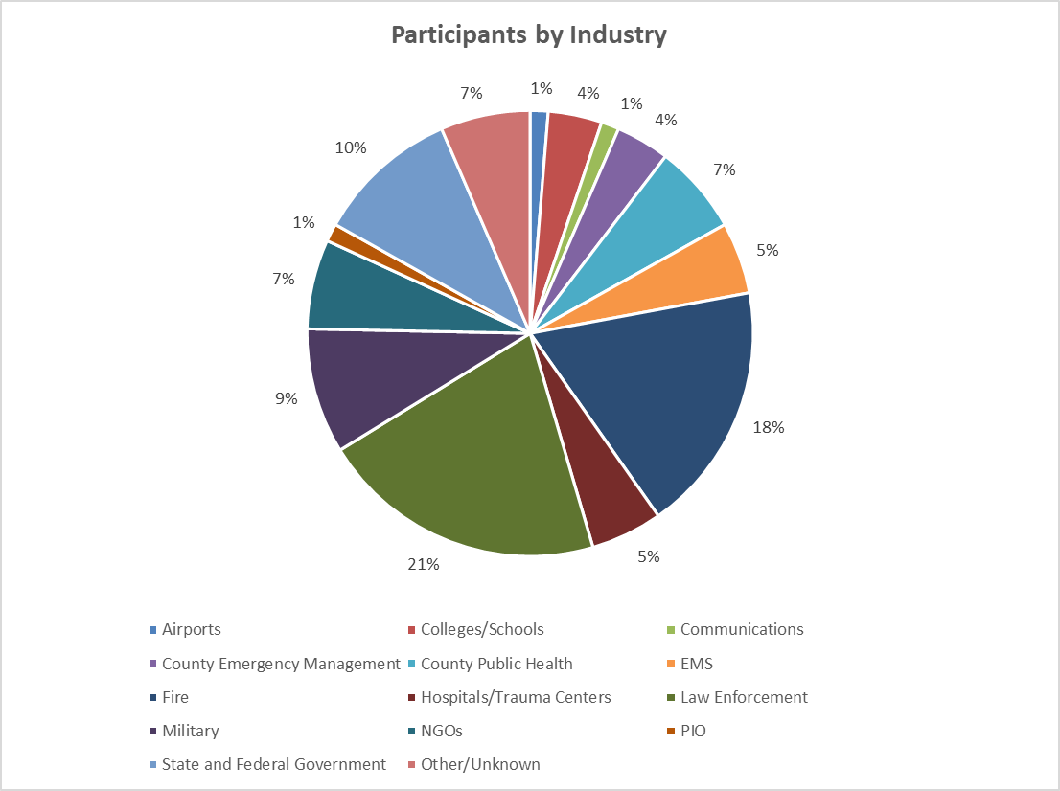

There were sixteen considerations resulting from the event:
- Distinguish the differences between Incident Command, Emergency Operations Center, and Joint Task Force roles to ensure seamless response and delivery of resources. Look at the transition from the private sector (Boeing and the railroad) and government response and the delivery of resources (what is brought, how much does it cost, and more). Work with elected officials to help with efforts. How can planning be improved among all partners, including Mexico?
- Explore how all partners – including schools and hospitals – may be notified early so they can prepare. There are examples of practices in other parts of the state.
- Work with military bases and military groups – including medical facilities/clinics – to better understand the costs and requirements for supplementing staff and capacities (example: hospitals may integrate medics to help with shortages, but agreements must be made ahead of time and the hospitals must have these resources within their emergency operations plans). This is particularly important with cascading events. As a reference, hospitals and public health are advised to look at the January 2026 Joint Commission requirements. Include discussions with the 91st Civil Support team.
- Examine the resources that the Customs and Border Patrol can bring.
- Identify how resources from other parts of the state may be moved via aircraft, including staff and supplies (Aviation Coordination Team within DEMA). While most regions look at resources transporting via roadways, there are other methods for rapidly getting what is needed.
- Explore how the County Public Health and hospital fatality capacities may be supplemented.
- Discover methodologies to offer external resources for decontamination to prevent contaminated individuals (could be worried wounded) from entering the hospitals and removing the hospitals as a crucial partner.
- Assist the schools/school district in identifying transportation of students, staff, and volunteers during evacuation.
- Read the Crisis Standards of Care (and updates) on triage of patients when resources are scarce or depleted. Refer to the Arizona Department of Health Services’ EMResource for diversion information.
- Work with the Public Information Offices to ensure continuity/consistency in messaging, including that which is sent to the most vulnerable (access and functional needs populations).
- Partner with the Arizona Health Care Association (AHCA) to assist with evacuations of nursing homes.
- Identify opportunities for training and cross-training and training with new partners (hospitals, schools, long-term care, and the private sector).
- Establish how to include the National Weather Service in planning as well as during an incident.
- Identify Family Reception Sites and Family Assistance sites separate from school reunification/reception sites (can refer to the resources at https://coyotecampaign.org/family-reunification/ with the knowledge that the Arizona Department of Education and others are updating the school reunification and referral planning guide). Also, identify patient tracking strategies.
- Identify how to get people across the border during an emergency, including partners who are there to help.
- Consider signing on to the Arizona Mutual Aid Compact (AzMAC), if this has not already been done.

