Healthcare Recruitment and Retention Forum Review

The Healthcare Recruitment and Retention Forum (Forum) was held on September 16, from 8:00AM to 3:15PM. The event location was the Desert Willow Conference Center (4340 E Cotton Center Blvd, Phoenix, AZ 85040). A total of 49 individuals attended the Forum. Attendance is displayed on the next page. AzCHER and the Collaborative sponsored the Forum, while ADE and ADHS contributed significant in-kind services during the event.

There were four main objectives that guided the event. By the end of the event, participants were to have a clearer understanding of:

1. Recruitment/retention barriers:
a. Generational differences in communications and work preferences (examples: younger populations may not be interested in retirement benefits and desire flexible hours).
b. Access and functional needs capacities to perform jobs, but challenges with interviewing processes.
c. Hiring durations impacting recruitment.
d. Housing and transportation issues impacting worker retainment.
e. Reciprocity challenges and potential recruits already trained in another state.
f. Other artificial or real barriers to careers.
2. Talent pipelines:
a. Junior High School career acquaintance opportunities.
b. Potential partnerships with career technical education programs (vocational schools) and community colleges.
3. On-the-job training programs:
a. On-site, integrated training opportunities and mentorship programs.
b. Apprenticeships, professional career onboarding, and internships.
c. Transitions to practice.
4. Best practices in recruitment and retention:
a. Incentives (examples: customized counseling services, access to child care, athletic trainers and equipment, loan forgiveness, and others).
b. Fast-tracked certifications.
c. Recruitment of experienced professionals for application of their skills and expertise in a new field.
d. Military outplacement (Department of Defense SkillBridge).

Evaluations conducted during the event showed improvements on all objectives as a result of the event.

The following scenario was used to foster discussion among the participants:

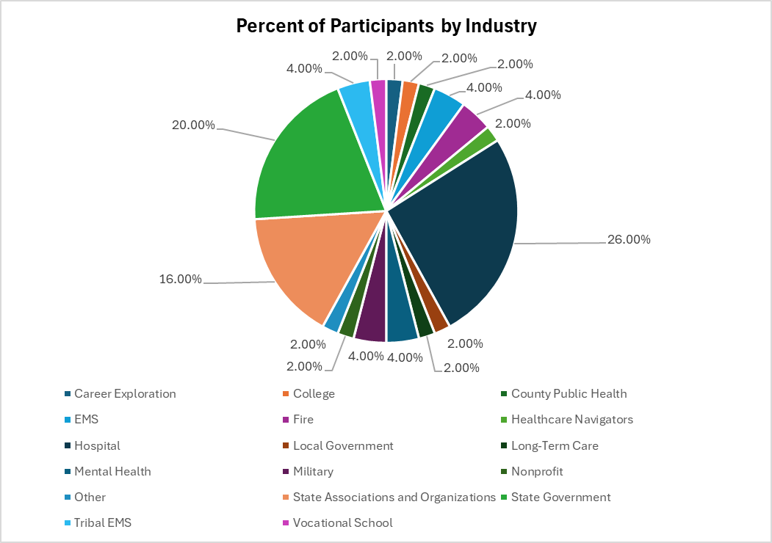
The discussion noted above contains many insights (recommendations apply to all participants).
- Determine how multi-generational recruitment communications (including those for access and functional needs, non-English speakers, diverse races, and rural/tribal regions) may be modified to reach the broadest audiences.
- Focus on career-based messages with lateral movement opportunities (i.e., there are many jobs within the industry to choose once the applicant is hired, including moves from night shifts; skills are portable from within the industry as well as external, such as EMTs to nurses), the positive culture present within the industry, and the reason the job matters.
- Explore alternative benefits package options, such as higher starting salaries (full-scale change, including existing workers; may replace retirement benefits), working from home as long as productivity demonstrates good outcomes (stop punitive practices for at-home work, such as removal from promotions) and is possible, as well as flexible hours (6, 8, and 12-hour shifts as well as hours to accommodate individuals without access to child, access and functional need, and elderly day care).
- Train leaders and mentors to foster welcoming environments (example: the Navajo Nation sent all field supervisors through EMS leadership team training for 8 months and it worked) and remove leaders and mentors unable to achieve desired results following training.
- Provide training that is customized for night shifts and takes advantage of Artificial Intelligence videos.
- Offer loan repayment, housing and relocation support, child care tuition discount/scholarship/other support, and alternative benefits package options.
- Expedite application processes.
- Explore Human Resource shifts to enable interviews to accommodate those without social skills for applicable positions (example: Neurodivergent applicants may not be able to manage interviews well but could perform jobs at an outstanding level).
- Encourage schools to provide dual course credits, career pathways, and career counseling (examples: Cadet and Explorer programs offered by fire departments and EMT credits in high school).
- Explore funding for high school fire and EMT certification programs through community colleges (example: In Kingman, the fire department partnered with the JTED program within the school and used funding from the Western Arizona Vocational District which is equivalent of West-Mec, which was a presentation made by Dr. Scott Spurgeon).
- If it extends beyond high school to community colleges for Fire and EMT training, I believe the students can use AZ Promise Program.
- Look at contractor positions in lieu of employment.
- Take advantage of the military’s SkillBridge program and consider establishing relationships with the National Guard and Active Duty.
- Partner with high schools, vocational schools, colleges, and universities.
- Encourage existing employees to recruit/mentor/role model their friends and family members and serve as a contact for healthcare positions and speak at job fairs and school events.
- Explore referral bonuses for existing employees, relocation bonuses, and professional development expenses.
- Re-examine targeted marketing and branding (example: Harley-Davidson has a reputation with certain targeted populations and easily recruits the employees they need).
- Explore partnerships for rural community healthcare position support with legislative funding (may require lobbying/advocacy).
- Examine paid internships and housing support, with particular attention to tribal and rural positions.

