**La Paz Reunification Significant Event Readiness Forum (SERF) Review**

The La Paz Reunification Significant Event Readiness Forum (SERF) was held on May 2, 2025, from 9AM to 3:00PM. The event location was the Blue Water Resort & Casino (11300 Resort Drive, Parker, AZ 85344). A total of 45 people attended the SERF. The event was a partnership between multiple agencies. The attendance is displayed on the next page.

There were eight objectives that guided the event. By the end of the event, participants were to have a better understanding of:

1. Roles and responsibilities of schools, first responders, hospitals, county/tribal public health, and municipal/tribal emergency management.
2. Notification processes.
3. Student, staff, and volunteer tracking for reunification.
4. Communication with community partners such as responders and hospitals with the schools.
5. Explore how Mutualink will work or aid in a scenario such as this, and other opportunities for interoperability.
6. Identifying new solutions/processes with the removal of Areas of Refuge from practice.
7. Schools will identify gaps and weaknesses in their reunification plans as it relates to people, processes, places, and items needed.
8. Assess the pediatric readiness of the two hospitals and how that impacts treatment and potential transport.

Evaluations conducted during the event showed improvements on all objectives as a result of the event.

Two scenarios were used to foster discussion among the participants:

First Scenario: A shooting has occurred at the Gryffindor School the first day after a weekend. The shooters have surrendered. Armed officers and the principal entered the classroom where the shooting occurred. As they entered, they were immediately mobbed by the students, all of whom were crying loudly.

The teacher is lying on the floor at the front of the classroom and is covered in blood. There are nine wounded students, two with access and functional needs. It is not immediately clear the extent of their injuries. EMS and Fire are at the scene.

The media have picked up the story and interrupted regularly scheduled programming with the

Second Scenario: It is now approximately 1 1/2 hours since the incident started. Police are escorting the students, staff, and volunteers towards police vehicles.

Reporters are now on the scene from every local media outlet. Several are trying to interview teachers and students to see how they feel about the incident.

Additionally, parents have arrived and are upset that they cannot pass beyond the police barrier to talk to school personnel and pickup their children.

Administrators are beginning to activate their reunification plan. There are students needing to be evacuated and reunified including several students with access and functional needs.

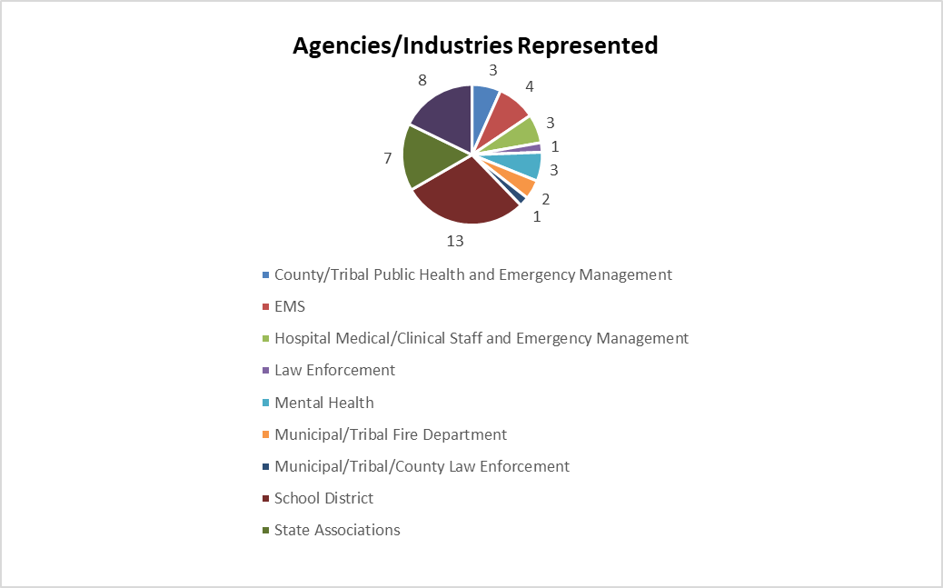

There were sixteen recommendations from the event:

1. Continue the practice of ensuring first responder familiarity with school properties and students (including new recruits) but ensure AFN populations are a priority (Go Bags and more).

2. Train additional responders and invite them to future trainings to create a more unified response. These potential responders include park rangers, border patrol, and any other responder who may hear the radio traffic and respond.

3. Obtain access for the fire department to Mutualink so they can more quickly and readily respond.

4. Establish in plans and training at what point Unified Command is established and formalized.

5. Establish procedures to track which patients went where, as well as identification aids. Consider how to relay important information to hospitals concerning particular patients, like custodial issues. Determine if school staff or volunteers will be deployed to act as liaisons.

6. Establish procedures to use phones and pictures with triage tracking to aid in victim tracking. Consider incorporating Mutualink to aid as well.

7. Integrate the Emergency Response Trailer into drills and other types of exercises to ensure the functionality is streamlined.

8. Establish procedures for security at the hospital in the event of a surge of patient since minimal to no security is currently available. Hospitals and law enforcement.

9. Create training opportunities between law enforcement and the hospitals to increase familiarity of systems, processes, and locations. Hospitals and first responders.

10. Establish procedures for reunifying staff (as well as students) with their family members following a large incident. Include communication procedures for staff families.

11. Regardless of the size and scope of schools, including AFN students and staff in exercises is a key component of disaster planning/preparedness. It is crucial to integrate AFN populations into all disaster exercises.

12. Train with mental health resources such as mobile crisis teams to gauge how long it will take as well as to determine what type of resources will be fully available.

13. Collaborate with the partners that prioritize pediatric readiness, such as EMS for Children as well as the Arizona Chapter of the American Academy of Pediatrics’ Pediatric Prepared Emergency Care (PPEC) program.

14. Participate in ADE and Trust’s School Consortium program

15. Participate with La Paz County Public Health and Emergency Management in preplanning and tabletop exercises.

16. Work with hospitals in La Paz to integrate first responders and mental health into exercises.