**Yuma Airshow Significant Event Readiness Forum**

**(SERF) Executive Summary**

SERF Details: The Yuma Airshow Significant Event Readiness Forum (SERF) was held on February 5, 2025 from 8AM to 3:00PM. The event location was the Cocopah Resort & Conference Center (15268 S Avenue B Somerton, AZ 85350). A total of 111 attended the SERF. The event was a partnership between multiple agencies. These partners served on the planning committee and guided decisions made for the event.

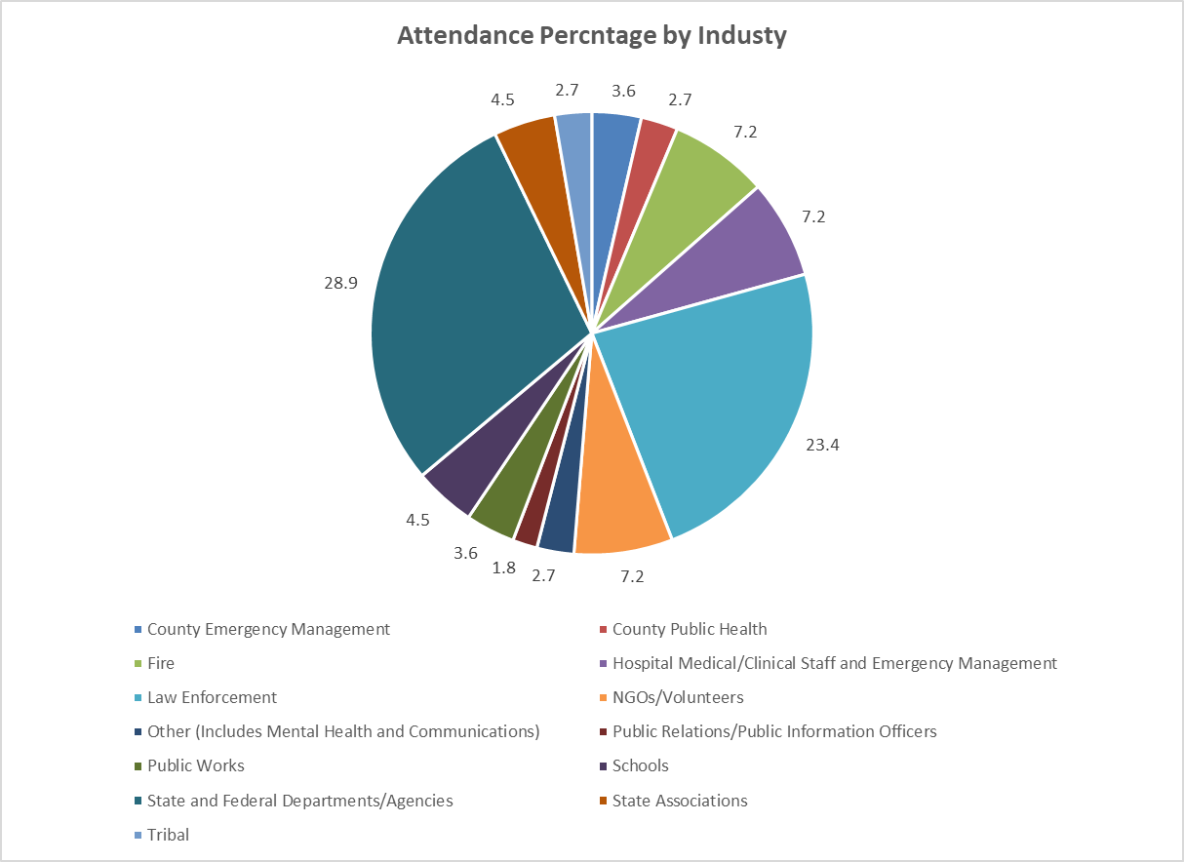

There were thirteen objectives that guided the event.By the end of the event, participants were to have a clearer understanding of:

1. Unified and/or Other Incident Command is established.
2. Mutual Aid Agreements will be activated (and what will be provided).
3. Scene security and management will occur (including traffic routing).
4. Hospital emergency plan will be activated (and what will be provided).
5. County emergency management activation of the Emergency Operations Center will occur (and what will be done).
6. County public health will send requests to the Arizona Department of Emergency and Military Affairs (e.g., requests to the Arizona Department of Health Services).
7. Marine Corps Air Station Emergency Operations Center will be activated (and what will be provided).
8. Joint Information Center messaging will align among partners.
9. Joint Information Center public notifications will occur.
10. The hospital will manage pediatrics, access and functional needs patients, and critically injured patients.
11. Tribal reunification and decedent notification will occur.
12. School reunification and decedent notification will occur.
13. Marine Corps Air Station reunification and decedent notification will occur.

Two disaster scenarios were used to spur discussions: Scenario 1: A military aircraft crash at a busy intersection during Airshow practice (resulting in 21 fatalities, 25 critically injured). Scenario 2: A military aircraft crash into base housing during the Airshow (causing 4 fatalities, 14 injuries).

Evaluations conducted during the event showed significant improvements on all objectives.

The key considerations derived from the event were the following:

1. Emergency Coordination: The need for seamless unified command among military, federal, state, and local agencies.
2. Hospital Surge Capacity: Addressing resource shortages, patient triage, and mental health support.
3. Security & Traffic Control: Managing on-site law enforcement, perimeter control, and transportation logistics.
4. Public Communication: Developing clear, accessible, and real-time messaging to counter misinformation and guide public response.
5. Family Reunification & Victim Support: Ensuring proper next-of-kin notification, reunification processes, and mental health services.
6. Infrastructure & Resource Planning: Evaluating the availability of emergency transport, airspace management, and alternative medical facilities.
7. Recommendations for Improvement:
8. Establish pre-vetted mutual aid agreements and crisis communication protocols.
9. Enhance training on Crisis Standards of Care and resource-sharing between military and civilian responders.
10. Develop a Business Operations Center for rapid outreach to the local business community.
11. Improve pediatric emergency care coordination given hospital limitations.
12. Address access and functional needs (AFN) populations in emergency planning.
13. Review Arizona drone laws and integrate FAA/FBI guidance into security protocols.
14. Strengthen transportation logistics and evacuation plans for large-scale events.

The Yuma SERF successfully identified critical gaps in disaster response coordination and provided actionable recommendations to improve multi-agency preparedness, medical response, and public safety measures for future large-scale events. Planners will be queried in August 2025 to determine changes made as a result of the SERF.