Hogwarts Reunification Targeted Event Readiness Forum (TERF) Executive Summary

The Hogwarts Reunification Targeted Event Readiness Forum (TERF) was held on August 16, from 8:00AM to 3:15PM. The event location was the Desert Willow Conference Center (4340 E Cotton Center Blvd, Phoenix, AZ 85040). A total of 102 individuals attended the TERF. The event was a partnership between the ADE, ADHS, the Trust, and the Collaborative.

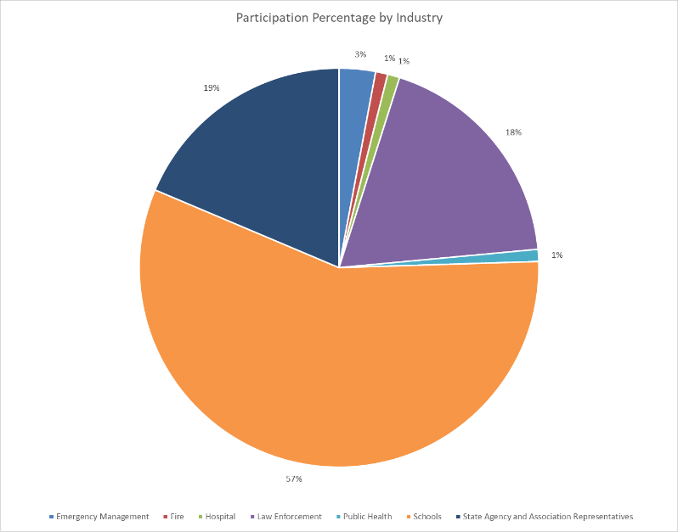

The event was organized by a partnership including the Arizona Department of Education (ADE), the Arizona Department of Health Services (ADHS), and others, aiming to foster collaboration and information sharing across agencies for disaster response readiness, particularly in mass casualty and school reunification scenarios.

There were seven objectives that guided the event. By the end of the event, participants were to have a clearer understanding of:
- Roles and responsibilities of schools, first responders, hospitals, and tribal and municipal emergency management.
- Notification processes.
- Unified Command.
- Privacy issues (FERPA and HIPAA).
- Hospital needs and rationale for school liaisons in reunification.
- Tribal and municipal emergency management needs and rationale for family reunification liaisons.
- Student, staff, and volunteer tracking.
The event used school intruder and active shooter scenarios to drive discussions. The scenario involved a trio of armed intruders entering a school, leading to a mass casualty event requiring immediate response from school officials, law enforcement, and emergency services. The scenario progressed in stages to simulate real-time decision-making, including lockdown procedures, police negotiations, and reunification efforts, culminating in the safe resolution of the crisis and the management of parents and media.

Evaluations conducted during the event showed moderate or significant improvements on all objectives as a result of the event.

The top eight considerations derived from the event were the following:
- Determine how communication strategies will work among alarm rooms, hospitals, schools, emergency management, and first responders.
- Establish relationships with alarm rooms, hospitals, schools, emergency management, and first responders and exercise these. Ensure policies and procedures exist for assigning school district liaisons to hospitals and notify hospitals of the decisions made.
- Use school reunification sites (e.g., first responders should respect the school venue selections and not try to alter these).
- Do not use “Safe Areas” or “Fire Resistant Rooms” for Access and Functional Needs/Special Needs students in a fire as all students must be treated equally.
- Position Stop the Bleed kit, Narcan, and AED placements so that teachers, staff, and volunteers may access these (not just nurses).
- Train fire and law enforcement Alarm Room/Dispatch night staff to ensure they know what to do in an after school program/sporting event after school hours.
- Develop policies and procedures on release of students following an incident (example: K-8 may be different than high school students). Regardless, the notification procedures should remain consistent for all students. Discuss these with law enforcement so alignment and agreement is secured.
- Establish routine meetings among all PIOs for seamless communications following an incident. Schools and School Districts, Hospitals, Emergency Management, Fire, and Law Enforcement.
- Use the PREPaRE Model established by the National School of Psychologists.
- Introduce crisis training in schools/school districts where such training does not yet occur.
The ADE will have a Guidance for schools completed in June 2025. National organizations have been contacted to assist with the removing the Areas of Refuge from fire and building code requirements; there is no safe area during a fire.

