**Pima County Multi-Agency Significant Event Readiness Forum (SERF) Executive Summary**

The Pima County Multi-Agency Significant Event Readiness Forum (SERF) was held on June 12, 2024, from 8:00AM to 3:30PM. The event location was the Desert Diamond Casino and Hotel (7350 S. Nogales Highway, Tucson, AZ). A total of 110 individuals attended the SERF.

There were 11 objectives that guided the event.By the end of the SERF, participants will have an improved understanding of:

1. How public information and warning will be activated and provided.

2. How operational coordination will be activated and provided.

3. How mass search and rescue operations will be activated and provided.

4. How public health, healthcare, and EMS services will be activated and provided.

5. How mass care services will be activated and provided.

6. How infrastructure systems and environmental quality will be assessed.

7. How critical transportation will be assessed and managed.

8. How fatality management will be activated and provided.

9. How forensic analysis and attribution of terrorist acts will be conducted.

10. How recovery will occur.

11. The cascading factors caused by the collision.

Evaluation conducted during the event showed significant or moderate improvements on all objectives as the result of the event.

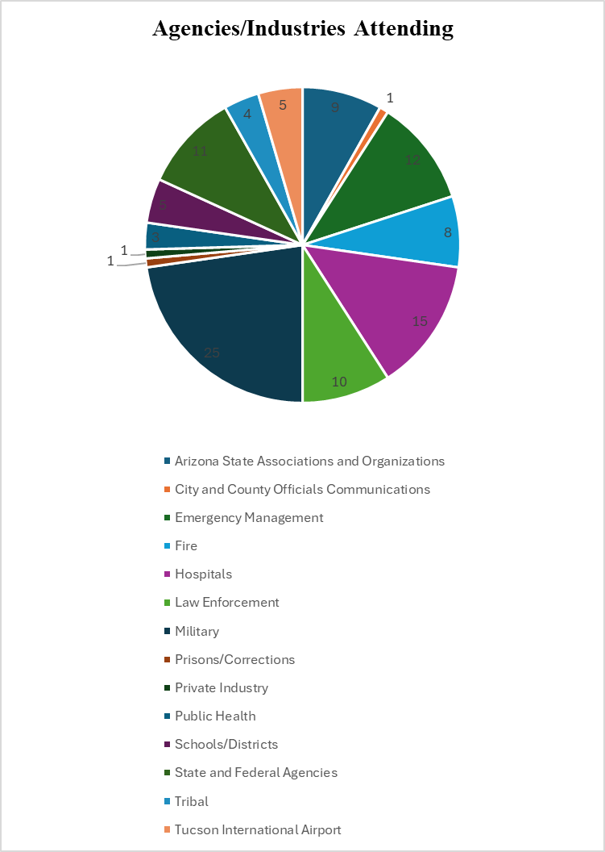

The following scenarios were used to foster discussion among the participants:

**First Scenario**

While on approach from maneuvers, one C-130 and one commercial regional jet (CRJ-100) collide in Tucson – by the Tucson International Airport – in the area of Campbell and Valencia. There are no survivors from the C-130 (five military officers killed), but the commercial jet is able to land (30 injured survivors out of 60 passengers and crew; the other 30 are deceased). The collision occurs over Sunnyside Unified High School while classes are in session and a park adjacent to the school. Fifty students, teachers, volunteers, or others are injured. A wing of the C-130 falls off the aircraft and lands at the school.

**Second Scenario**

While on approach from maneuvers, one C-130 and one commercial regional jet (CRJ-100) collide in Tucson – by the Tucson International Airport – in the area of Wilmot and I-10. There are no survivors from the C-130 (five military officers killed), but the commercial jet is able to land (30 injured survivors out of 60 passengers and crew; the other 30 are deceased). The collision occurs over the state and federal prisons. A wing of the C-130 falls off the aircraft and lands at both prisons. Fifty inmates and staff are injured.

The top eight considerations derived from the event were as follows:

1. Explore MCTRAC customization (technology and processes) to customize these for optimal application in Pima County. *County, tribes, and municipalities.*
2. Explore all reunification planning guides for customization, definitions, and application with particular attention to the need for liaisons and access and functional needs accommodations (example: schools have images and custodial information). *Schools, hospitals, municipalities, tribes, and hospitals.*
3. Examine Crisis Standards of Care requirements from ADHS. *Hospitals.*
4. Develop and share pediatric victim plans for transport and treatment (e.g., what are the capacities to accommodate pediatrics?). *Hospitals, fire, and EMS.*
5. Establish relationships among schools, fire, hospitals, and law enforcement to ensure there is a clear understanding of roles and responsibilities after an MCI. *All groups noted above.*
6. Host meetings among fire, military, law enforcement, prisons, FBI, airport, communications, and border patrol to identify – as possible – opportunities for improved communications and clearer understandings of hazardous materials on aircraft. *All groups noted above.*
7. Deconflict cooling options for first responders and consider caching equipment (example: tents and cots). *First responders; county public health; county, tribal, and municipal emergency management; and military.*
8. Explore the creation of Crisis Response Teams. County, tribal, and municipal emergency management.

Findings are forthcoming and will not be assessed for six months (December, 2024).