Tempe Aircraft Accident Targeted Event Readiness Forum (TERF) Executive Summary

The TERF was held on June 15, 2022, from 7:00AM to 3:30PM at the Desert Willow Conference Center (4340 E Cotton Center Blvd, Phoenix, AZ 85040). A total of 125 individuals attended the event. Attendance is displayed on the next page.

There were nine objectives that guided the event. By the end of the TERF, participants were to have determined how:
- Public information and warning will be activated and provided (tribal/municipal public and business alerts, media management, and Joint Information Coordination).
- Operational coordination will be activated and provided (Unified Command, Emergency Operations Center linkages, Multi-Agency Coordination Center activation and processes, radio communications [including frequencies], access and perimeter control, and identify verification).
- Mass search and rescue operations will be activated and provided.
- Public health, healthcare, and EMS services will be activated and provided (alarm room notification of hospitals, surge, decompression, and public health issues).
- Mass care services will be activated and provided (Hospital Reception Centers, the Emergency Call Center, Family Reunification Center(s), patient tracking, victim transport, mental health support, and shelters).
- Infrastructure systems (structural and roadway [National Transportation Safety Board, the office of the fire marshal, building inspector(s), and more]) and environmental quality will be assessed.
- Critical transportation will be assessed and managed (airlines, rails, and other mass transit).
- Fatality management will be activated and provided.
- Forensic analysis and attribution of terrorist acts will be conducted (including investigation leadership and linkages among responding organizations).
Evaluation conducted during the event showed significant improvements on all objectives as the result of the event.

The following scenario was used to foster the discussion: Stand-up paddle boarders, kayakers, pontoons, and six ASU sculling teams are on Tempe Town Lake. Nearby (southern Rio Salado Park area), multiple Developmental Disability service providers from the Valley are hosting a picnic with 50 clients (including non-ambulatory, visually-impaired, and nonverbal) and staff. In addition, a large child care center has a picnic with 100 children and supervising adults.

Over Salt River Pima Maricopa Indian Community (SRPMIC), a package distribution company is conducting an unauthorized test of an unmanned aerial system (UAS). SRPMIC Fire Department has just notified Sky Harbor of observation of the UAS presence.

While on approach into Phoenix Sky Harbor International Airport from Denver, Sonoran Airlines, Flight 48’s left engine is struck by the UAS. The engine ingested the UAS, causing a catastrophic, uncontained engine failure, damage to the leading edge of the wing, and damage to the aileron.

Upon declaring an emergency, the flight crew attempts to continue the approach into Phoenix Sky Harbor International Airport. Shortly after impact with the UAS, Flight 48’s left engine separates from the wing, spewing wreckage onto the SRPMIC soccer field. On its rapid descent, the aircraft hits the Arizona Public Service 230kV transmission lines to the Ocotillo Power Plant as well as the Salt River Project 230kV and 69kV transmission lines, sending additional debris across Tempe Town Lake, the bridge crossing McClintock Drive, and the southern Rio Salado Park area.

Unable to reach the airport, the aircraft crashes approximately 3 miles east of the airfield, within the city limits of Tempe. The crash impacts the following buildings: Honor Health Medical Group (35 patients and staff), State Farm Insurance (600 employees), Carvana, and Mountainside Fitness.

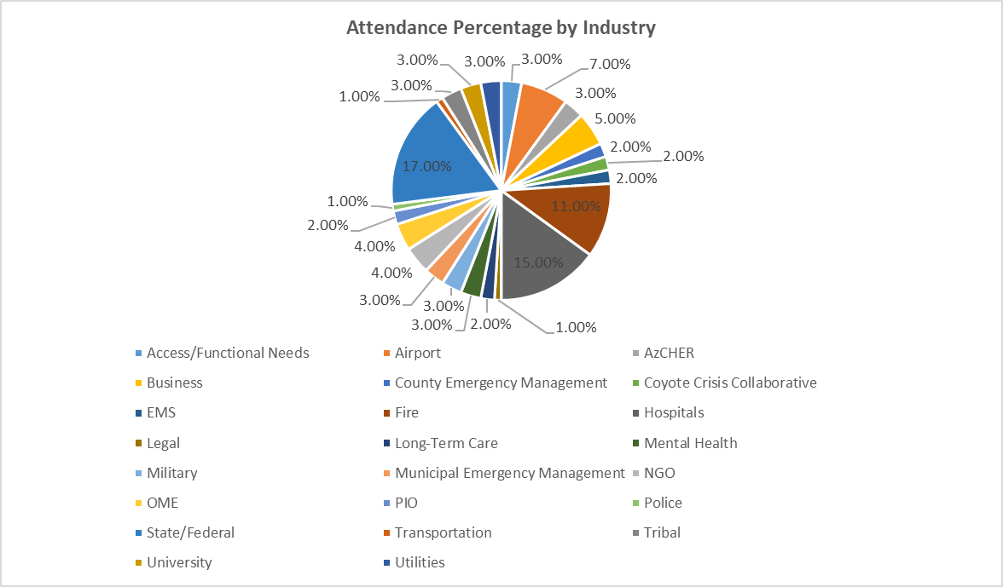

The top fifteen considerations derived from the event were the following:
- Revise Alert 2 and 3 airport protocols to notify municipal/tribal first responders, Arizona Department of Emergency and Military Affairs, ADHS, AzCHER, county emergency management and OME, and Mercy Care. Include Tucson International Airport on protocols/development.

- Identify law enforcement protocols for parking vehicles near scenes to avoid obstruction of fire and EMS asset movement.

- Define agencies/organizations that should be in a Valley Unified Command during an airport incident (regardless of where the aircraft lands).

- Solidify the pre-alert protocol for alarm rooms to send a message to hospitals BEFORE victim assessments are completed, remembering that the hospitals have already agreed that they would prefer a false alert to waiting for completion of victim.

- Develop a Standard Operating Procedure, with partners to identify communication chains, resources, and other information needed for improved communications.

- Identify and test a statewide patient tracking data set and/or technology to capture victim characteristics for reunification and notification.

- Develop a forward field medical/triage/surgical/extraction team model (composition, coordination, activation process, and protocol). Determine how law enforcement would validate that a forward medical/surgical/extraction team and given access to a scene.

- Develop a protocol for enabling non-injured populations dependent upon electronic devices (including wheel chairs) to keep their electronic devices in an MCI (including through decontamination. Relatedly, explore a protocol to ensure people with disabilities are not transported to hospitals or nursing homes if they are not injured and in need of medical care.

- Determine relief and mental health strategies for 911 systems, first responders, and hospitals.

- Determine if there is needed an EMS MCI compact to ensure cross-jurisdiction support.

- Establish a Business Operations Center (BOC) pilot project to communicate with businesses on evacuation sites and more.

- Identify PIO needs and partners (figure heads) for an aircraft MCI.

- Determine state assets to assist the OME in human remains recovery for an MCI.

- Explore what can be done to foster continuation and enhancement of law enforcement, enabling the FBI and other law enforcement to manage drones.

- Prioritize Valley municipal (and tribal) Family Reunification Center and Hospital Reception Site planning guides.

As a result of this event, the City of Tempe’s Assistant Fire Chief and Emergency Manager met with the Maricopa County Department of Emergency Management, Arizona Division of Emergency Management (DEMA), and Coyote Crisis Collaborative to discuss the potential of a victim tracking and reunification collaborative, which all entities supported (called the Mass Casualty Tracking and Reunification Arizona Collaborative, or MCTRAC).

A MCTRAC Executive Committee was created to advance the project. HonorHealth purchased software and developed the victim tracking capacity with the Executive Committee. Over one year, the MCTRAC Executive Committee met to refine processes and technologies as a result of hospital and first responder exercises. In addition, the Maricopa County Department of Public Health created a call center to support family member/friend data collection for victim matches (with multiple languages used and accommodations for access and functional needs populations).

Numerous presentations were made to other counties by the Tempe partners, all of which strongly supported the concept. However, the MCTRAC Executive Committee voted to delay advancing the project statewide for customization by other municipalities, tribes, and counties until training is completed and commitments are garnered from all needed partners. In the interim, DEMA has offered the counties access to the victim tracking capabilities for use in exercises and MCIs. Ultimately, MCTRAC will become a state resource housed under a state agency (most likely DEMA).

