Stadium Shooting Significant Event Readiness Forum (SERF) Executive Summary

Event Details: The Stadium Shooting SERF was held on June 19, 2023, from 8:00AM to 3:00PM. The event location was the Prescott Resort and Conference Center (1500 AZ-69, Prescott, AZ 86301). A total of 77 individuals attended the SERF. Attendance is displayed on the next page.

There were eight objectives that guided the event. By the end of the SERF, participants were to have a better understanding of:
- Communications.
- Public Information Office/Joint Information Center messaging.
- Command activation, structure staging, and strategies.
- First responder actions.
- Hospital response.
- Terrorism Liaison Officer (TLOs) response and coordination with the Arizona Counter-Terrorism Information Center (ACTIC).
- Investigations.
- Mental health support.
Evaluation conducted during the event showed significant improvements on all objectives as the result of the event.

The following scenario was used to foster discussion among the participants: An outdoor event occurred outside of a large event center in Prescott Valley. During the event, shots rang out from the roof of the event center. Law enforcement rapidly arrested the gunman without incident. The gunman had a radio set at a frequency for monitoring law enforcement communications.

A scan of the roof top area where the arrest occurred resulted in the discovery of ammo unusable by the shooter’s arms, indicating the possibility of a second shooter.

The scene around the event center is chaotic. Fifty-one people were wounded, and 13 others are dead, although others fled the scene and may also have been injured to some degree. The wounded at the scene included 6 children, one of whom was a relative of a Prescott Valley Town Council Member. Thirty-five of the known injured are critical, including one of the children.

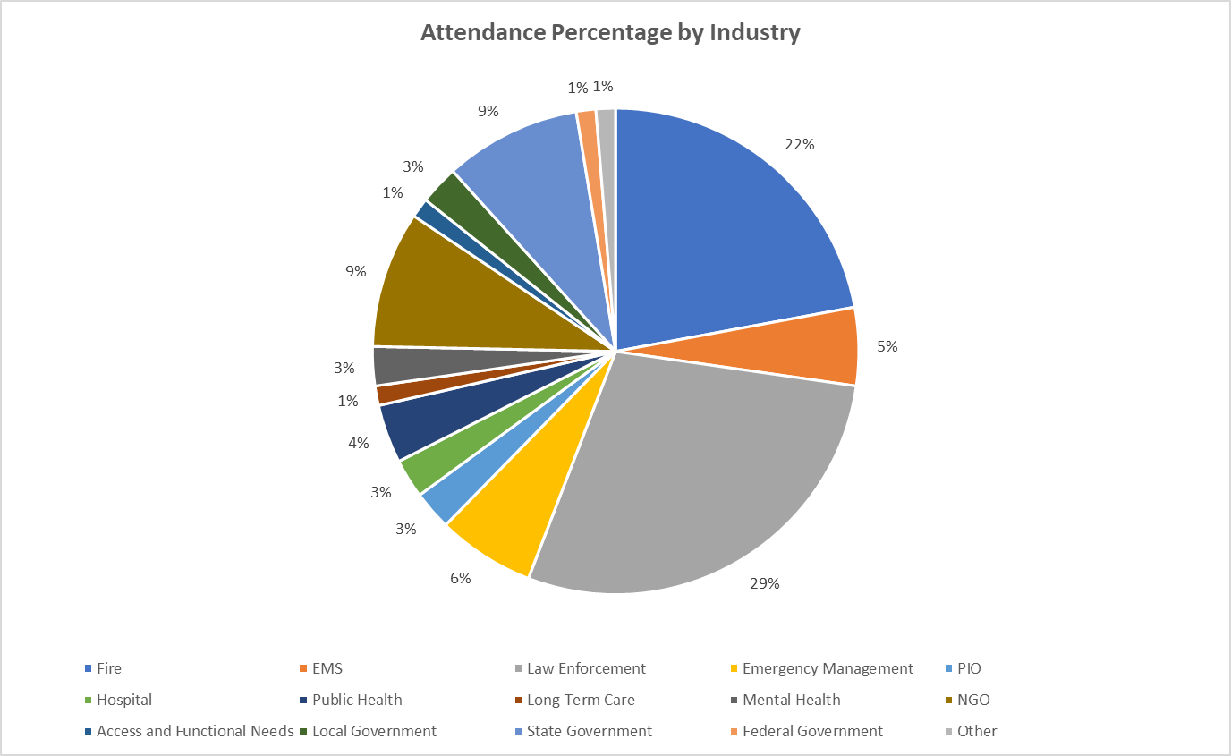

The top eight considerations derived from the event were the following:

- Include staging assignments and plans for law enforcement to avoid obstacles to EMS routes. Explore new routes for responder vehicles (including alternate landing zones) should there be ingress/egress barriers.

- Continue evolving a thorough list of entities that must be notified by dispatch during the first and second MCI notifications (hospitals, emergency management, OME, PIOs) and evolving emergency management roles and responsibilities. Request Call Center activation promptly (identify in plans) to divert calls that are being made to 911.
- Integrate the air branch into operations (plans) and test the capacities, including capture of resources from the Valley.
- Develop Standard Operating Procedures and training for law enforcement radio frequencies during a disaster response.
- Examine prioritization of first responder vehicle release from active scenes to enable use of all resources for response.
- Explore all options for drone use and “downing.”
- Locate and design primary and secondary Family Reunification Center. Simultaneously, activate resources to staff the Family Assistance Center.
- Explore decedent storage capacities at hospitals (supplement to the OME’s capacity) and track.

