School Access and Functional Needs/Complex Medical Needs Targeted Event Readiness Forum (TERF) Executive Summary

The TERF was held on June 5, 2023, from 8:00AM to 2:30PM. The event location was the Desert Willow Conference Center (4340 E Cotton Center Blvd, Phoenix, AZ 85040). A total of 134 individuals attended the TERF. Attendance is displayed on the next page.

There were three objectives that guided the event. By the end of the TERF, participants were to have a better understanding of:

- Strategies that can ensure necessary resources, including staff, supplies, and equipment that are able to support students and staff with Access and Functional Needs (AFN)/complex medical needs (including mental health needs) during an emergency, including an active shooter incident.
- The importance of a) why students and staff with Access and Functional Needs (AFN)/complex medical needs (including mental health needs) should participate in emergency response drills and b) the tools and methodologies that may enable these students and staff to participate in emergency response drills more successfully.
- Have a better understanding of current laws impacting emergency planning for students and staff with Access and Functional Needs (AFN)/complex medical needs (including mental health needs). This topic was not formally presented due to time.

Evaluation conducted during the event showed significant improvements on all objectives, except for the third objective, as the result of the event.

The following scenarios were used to foster discussions in two distinct discussions:

Scenario 1: It is a partly cloudy day in April. The temperature is 35 degrees, and the wind is blowing at 10 miles per hour from the northwest. At 1:30 p.m., the campus is rocked by an explosion. You are unsure of where the explosion has occurred and whether it is on campus.

A staff member contacts you to let you know that the explosion occurred in a maintenance storage room located near the northwest corner of the building. There is fire activity in the area.

The extreme cold has forced the boilers running the heat system to stress. A spark in the boiler room ignited some leaves and paper that had not been cleaned up. Pallets stored nearby added fuel to the smaller fire and the fire began to gain momentum. The fire alarm goes off, and the smell of smoke ensures that everyone has a sense of urgency in evacuating all students.

Scenario 2: As students arrive at school on the first day after spring break, a woman enters the school through the bus entrance with the student population. Because the teachers on bus duty recognize the woman as a parent and the spouse of a special education teacher, no one stops her from entering the building. The woman does not report to the office and goes directly to her husband’s classroom, where her husband (the teacher), students and staff are inside.

The woman enters her husband’s classroom, pulls a handgun from her purse, and screams at her husband. She shoots her husband three times in the stomach and runs out of the classroom. Popping sounds have been heard in the school. The school principal has placed the school on lockdown.
As law enforcement arrives, the shooter is neutralized in the first few minutes. The school remains in lockdown for three hours, while law enforcement searches for a second shooter. No school buses, school vans, or parental vehicles have been permitted access to the school.

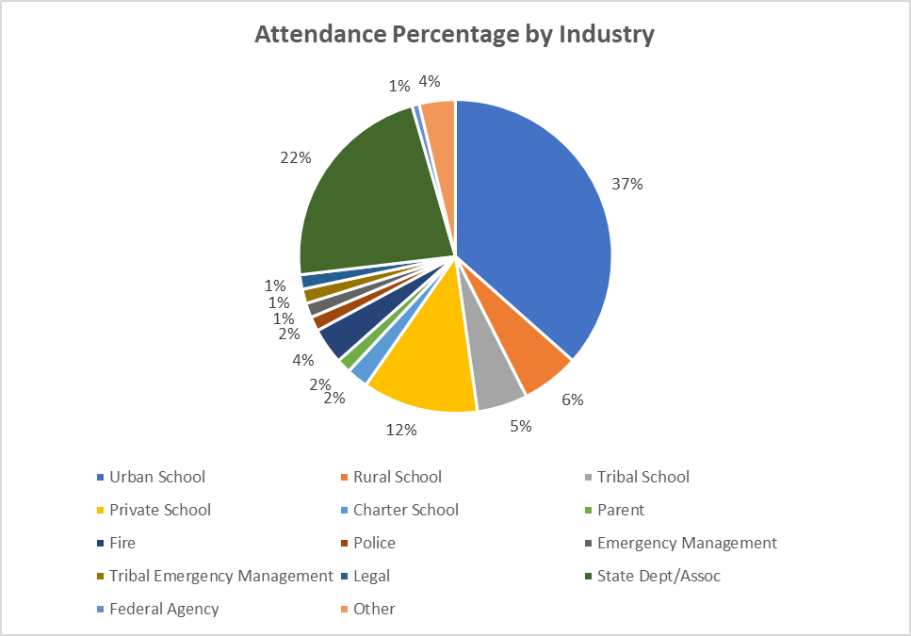

The top sixteen considerations derived from the event were the following (an extended list is offered due to the two scenarios):

- Establish working relationships among schools, districts, law enforcement, fire, and local emergency managers as referenced in the EOP template and share Individual Safety Plans (ISPs) with local fire departments and law enforcement, particularly pertaining to students requiring medical attention from school nurses during disaster response.

- Coordinate opportunities for designated school and district special education staff to attend Incident Command System (ICS) training to ensure familiarity with the ICS and terminology.

- Develop plans for ensuring that student medications are accessible to them in the event of a school evacuation or lockdown (diabetes medications and testing equipment, epi-pens, and inhalers can be carried by students). One designated person – such as a nurse – is insufficient to accomplish the task as this person may be incapacitated, ill, not on-site, or unable to reach one or more of the students. Other staff (teachers, transportation drivers, administrators, and so forth) may need to have a list of those who self-carry as well.

- Explore the supports needed during emergency response in the IEP, to include detailed information about a student's medical condition, required medications, medication delivery times, other regimens, equipment, emergency contacts, specific instructions for emergencies, skill deficits that may impact the student’s ability to participate or maintain safety during an emergency, and more that is customized to the needs of each student. The supports can be addressed in the IEP through accommodations, supplementary aides and services, direct instruction related to emergency response. Examine the prospect of the IEP team creating a separate Individual Emergency Safety Plan.

- Explore integration of a special education representative on regular district/school Safety Plan team meetings.

- Consider extreme weather as it relates to the students’ medical needs (heat, rain, snow, and wind).

- Hold drills in accordance with the minimum requirements, assuring that all students and classrooms should be included.

- Reach out to local responding agencies to discuss the equipment and medication needed by students with access and functional needs during an evacuation or lockdown. For example, if local law enforcement only allows clear bags during an evacuation, clear bags can be used. Consider placing the clear bags in colored bags to protect student privacy; these clear bags may be removed during a disaster.

- Establish practices to include necessary items for the population served in Go Bags (multi-use blankets, earphones, stuffed animals, IPAD, and other). Items for consideration may include medication and regimen instructions, the individual safety plan, diapers, wipes, batteries, first aid kit, emesis bags, and other supplies. Consider storing some items in local, law enforcement-improved backpacks or attaching the items to student equipment (wheelchairs). Discussions with parents are crucial for determining optimal strategies and supplies.

- Develop plans to ensure communication devices sent with students who depend upon these are the equipment with which the students are familiar.

- Determine how to configure a 1:1 ratio for student evacuation as required by the disability (students with mobility challenges and students who run, as examples). This might be accomplished by assigning non-special education staff to special education classrooms (custodians, library aides, clerical, and cafeteria staff, as example). Back-up planning should consider additional assignments to ensure the ratio. Remember, buddy systems place other students in possible danger.

- Train back-up personnel (may be an emergency medical response team with clearly defined roles and responsibilities) who can step in and provide medical support to complex medical needs students in the absence of a school nurse in preparation for an evacuation/extended lockdown (administration of student-specific medication needs as an example and familiarity with the location of supplies and equipment). Discuss processes established for the absence of a nurse with guardians and exercise the strategies employed for the lack of nursing presence at a school during a disaster.
- Consider having duplicates of commonly used health office items in Go Bags. Equipment and supplies should be clearly marked and inspected routinely to ensure shelf life.

- Address strategies that promote and fund the practice of ensuring one nurse is assigned to every school.

- Pre-determine evacuation routes and locations and alternative routes and locations. The routes and locations should consider the safety of students and staff, including students with access and functional needs. Explore using a separate access/egress for students with access and functional needs in evacuation plans for specialized transportation.

- Cross-training teachers, paraprofessionals, related service providers, and administrators in Stop-the-Bleed (work with the Trust, first responder entities, and/or hospitals), suctioning, operation of medical equipment, and other practices which may be needed for students with complex medical needs and mobility devices during a disaster.

- Explore locating classrooms serving students with mobility disabilities on the first floor. If not, purchase med sleds or evacuation chairs for students with mobility disabilities on every floor accessed by the students during a normal school day. It is important to advocate that students with access and functional needs not be assigned to “safety areas.” Schools, fire, and law enforcement have no way of determining the time it may take to reach the student and meet the needs of the student during the emergency (medical treatment, as an example).

- Hold a conference/regional meetings on laws impacting emergency planning for students and staff with access and functional needs/complex medical needs (districts/schools may not be aware of liabilities and financial consequences) to include special education directors.
As a result of this event, TERF planners were reconvened to address each finding. These findings led to the development of new Arizona Department of Education Guidelines and training plans by the TRUST and the attorneys guiding schools pertaining to AFN populations. In addition, there were two major recommendations offered by the planners:
      - Schools must have no-notice drills as current practices enable schools to notify parents ahead of time so they are able to keep students at home.
      - No “safe areas” should be used in a drill or event as there are no safe areas (example: during a fire).
In addition, as of 2023, the Arizona Auditor General’s Office contacted a number of the planners reconvened to address the TERF findings to provide insights on school disaster planning.

