National Pediatric Disaster Conference Significant Event Readiness Forum (SERF) Executive Summary

The SERF was held on October 27 and 28, 2022, from 8:00AM to 3:00PM. The event was originally designed to be an in-person conference held at WestWorld in Scottsdale. Due to an anticipated elevation of pediatric patients in hospitals (flu and COVID), a decision was made to move the conference to Zoom. However, presenters and staff met at the Arizona State Emergency Operations Center (SEOC) at 5636 E McDowell Rd, Phoenix, AZ 85008 for coordination purposes. A total of 211 individuals attended the event on day 1, while 155 individuals participated on day 2. Due to pediatric surges across the nation, numerous registrants notified the Collaborative that they would not be able to attend. Most of the absentees were from hospitals or public health. Attendance is displayed on page 3 for both days.

The Goal of Day 1 was to establish a framework for understanding command structure(s) and situational awareness as well as to determine first responder, private sector, and military staging, triage, and transport of pediatric.
Day 1 Objectives:
- Improved understanding of California’s local and state command structure(s), situational awareness, resources, limitations, and resource distribution; and
- Improved understanding of first responder, military, and private sector staging, triage, and ground and air transport (including routes).
The Goal of Day 2 was to identify legal and mental issues and clarify hospital pediatric evacuation needs, considerations, resources and resource coordination, communications, reunification, and challenges.

Day 2 Objectives:
- Improved understanding of legal and mental complexities of hospital interstate evacuations during a catastrophic incident.

- Improved understanding of healthcare capacity status identification, hospital needs assessments, communication strategies, and essential elements of information collection during a catastrophic incident.

- Improved understanding of the transfer of patient information among healthcare systems during a catastrophic incident.

- Improved understanding of patient tracking in healthcare systems and agencies supporting family reunification during a catastrophic incident.

- Improved understanding of hospital pediatric patient reception best practices and challenges during a catastrophic incident.

Evaluations conducted during both event days showed significant improvements on all objectives as a result of the SERF.

The following scenario was used to foster discussion among participants on the both days (two distinct periods): Thursday, October 20, 2022, at 2:12PM a magnitude 7.7 earthquake hit Southern California. The epicenter is located near downtown Riverside, California. Multiple aftershocks are still being experienced. Reports indicate:
- There are mass electricity outages in Riverside, Orange, Los Angeles, and San Diego counties.
- Cell towers are overloaded and/or non-operational.
- Fresh water and sewers have been compromised in the areas directly impacted by the earthquake.
- There are multiple gas line fires and explosions, with significant injuries being reported.
- Many highways and roadways are not accessible north and east of the epicenter due to surface damage, serious accidents, and congestion.
- San Bernadino and Riverside airports are non-operational, due to structural damage, and traffic is being diverted.
- All other Southern California international and municipal airports are limited to emergency flights only, but operational.
- The sea ports of Los Angeles, Long Beach, Newport Bay, Dana Point, Oceanside Harbor and San Diego Harbor are reporting operational, but diverting incoming traffic.
  - A significant number of hospitals in Los Angeles, Orange, Riverside, Southwest San Bernardino, and San Diego counties have reported structural damage, electrical, HVAC, generator, and water outages, and may need to evacuate.
  - Numerous California hospital capacities, blood, supplies, and resources are severely depleted and must send some patients out of state; they can’t decompress any more.
  - Children’s Health of Orange County and Loma Linda University Children’s Hospital are on fire with significant injuries, many with burns; these hospitals are evacuating.
  - An overwhelming number of local victims are arriving at hospitals in California via private vehicle (some are walking wounded, while others are presenting with serious injuries).
  - Impacted hospitals have “recalled” staff but are reporting an average of 25% response rates.
  - Hospitals in states adjacent are triaging patients and sending them east; they are overwhelmed with surges and are anticipating the need for additional resources and supplies.

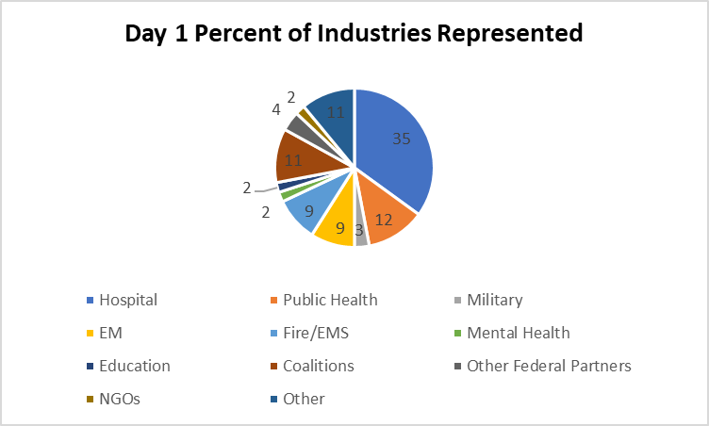

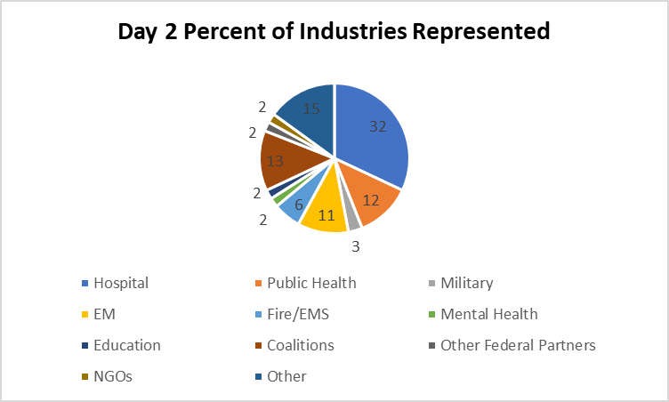

The top ten considerations derived from the event were the following:
- Develop and test plans for interoperable interstate communications, coordination, and response during the onset of a catastrophic incident. This should include identification of:
- A pre-identified radio frequency for use by the military and first responders.
- Pediatric air transport management (coordination responsibilities, viable aircraft, needed equipment and supplies, and staffing (is it better to use military nurses on military aircraft or is it better to send a nurse who is familiar with the patient?).
- Chain-of-custody ambulance transport to airports determined to be safe for operations.
- Mid-way and/or border triage, stabilization, and transport staging sites as well as field hospitals. Identify who will staff these as well.
- Integration of National Guard, Active Duty, and Reserve representatives in the state emergency operations centers.
- Medical asset de-confliction strategies (e.g., will anyone really benefit if doctors and nurses are deployed away from hospitals to serve in military responses?).
- Integration of lessons learned from the Israeli response to the Haiti disaster.

- Clarify liability coverage for volunteers crossing state boundaries for response (refer to the legal document created by Prof. James Hodge to all hospitals (https://wrap-em.org/).
- Create an environment to support military training and response for pediatric injuries and transport.
- Determine a funding source for pediatric patients to return from hospital destinations (repatriation) once the patients are stabilized and able to return home (applies to non-federally transported cases; NDMS does not transport pediatrics at this time).
- Identify pediatric equipment funding for EMS and distribute funding (for equipment and supplies), potentially using caches sited in hubs across a state.
- Identify a national standardized system of determining the pediatric patients who can be moved versus those who should not be moved (in-hospital triage).
- Ensure all facets of reunification are planned, able to be staffed, and tested.
- Create an incentive for hospitals to work together pertaining to resource sharing, patient transport among different hospital systems, and more. The financial incentives were lost in parts of the country when ASPR discontinued full funding to the state health departments (coordination) and hospitals and instead opted to launch health care coalitions, which may have no operational role in disaster response.
- Publish with fire, EMS, and others the best practices on mental health and other types of support for hospital workers, first responders, and their families.
- Evolve a standardized web-based health information exchange project for use with diverse hospitals to use during disasters. As patient tracking platforms across the country have demonstrated, challenges arise when the federal government permits unique systems to develop that won’t “talk” to each other. There is an opportunity to shift the vision.

