Country Thunder-Railway Incident Significant Event Readiness Forum (SERF) Executive Summary

SERF Details: The Country Thunder-Railway Incident Significant Event Readiness Forum (SERF) was held on February 20, 2024, from 8:00AM to 3:00PM. The event location was the Encanterra Country Club Ballroom (36460 N. Encanterra Drive, Queen Creek, AZ). A total of 88 individuals attended the SERF. Attendance is displayed on the next page.

There were 11 objectives that guided the event. By the end of the TERF, participants were to have determined how:

1. How public information and warning will be activated and provided.
2. How operational coordination will be activated and provided.
3. How interoperable communications will be established (including triggers and communications with hospitals, prisons, transportation, and municipal, tribal, and county management).
4. How situational assessment will be activated and provided.
5. How ingress and egress traffic will be managed.
6. How law enforcement will be coordinated (including security) in conjunction with fire (pertaining to toxic chemicals; where will patients be routed).
7. How fire and EMS services will be activated and provided.
8. How hospitals/healthcare will be notified, coordinated (number of patients hospitals can take [staffed beds] and level of care capability) provided.
9. How public health will be activated and provided.
10. How environmental hazards will be managed (includes protective measures for first responders).
11. How fatality management will be activated and provided.

Evaluations conducted during the event showed improvements on all objectives as a result of the event.

The following scenario was used to foster discussion among the participants: It is Saturday night of Country Thunder and more 30,000 event attenders are present during a head liner event. As is usual for this evening, many individuals are intoxicated.

The evening winds are gusty and erratic (between 30 to 50 miles per hour and shifting directions). Rains have begun, with heavy showers predicted.
Security notices an RV driver swerving towards the Copper Basin rails on Hunt Highway and Oasis Lane/Road. Unfortunately, security is unable to deter the driver who crashes into multiple Copper Basin rail cars carrying sulfuric acid.
The crash causes a derailment and wreckage, hitting multiple vehicles in the vicinity, sparking fires among some of the vehicles, killing the officer who had nearly reached the RV, and killing or wounding all of those in the vehicles parked near the Copper Basin rails. Some of these vehicles likely contained sleeping children.
The combination of sulfuric acid and rain causes a massive explosion, sending a toxic plume across Country Thunder attenders and the performers on stage. The toxic plume is headed directly towards Florence (including the prisons). Later, the winds cause a reverse in the direction of the plume and heads towards the Army National Guard Base.
The scene is horrific. (Vehicles attempting to leave the scene aren’t following instructions by the Florence Police Department and are driving off the single road providing egress and ingress.
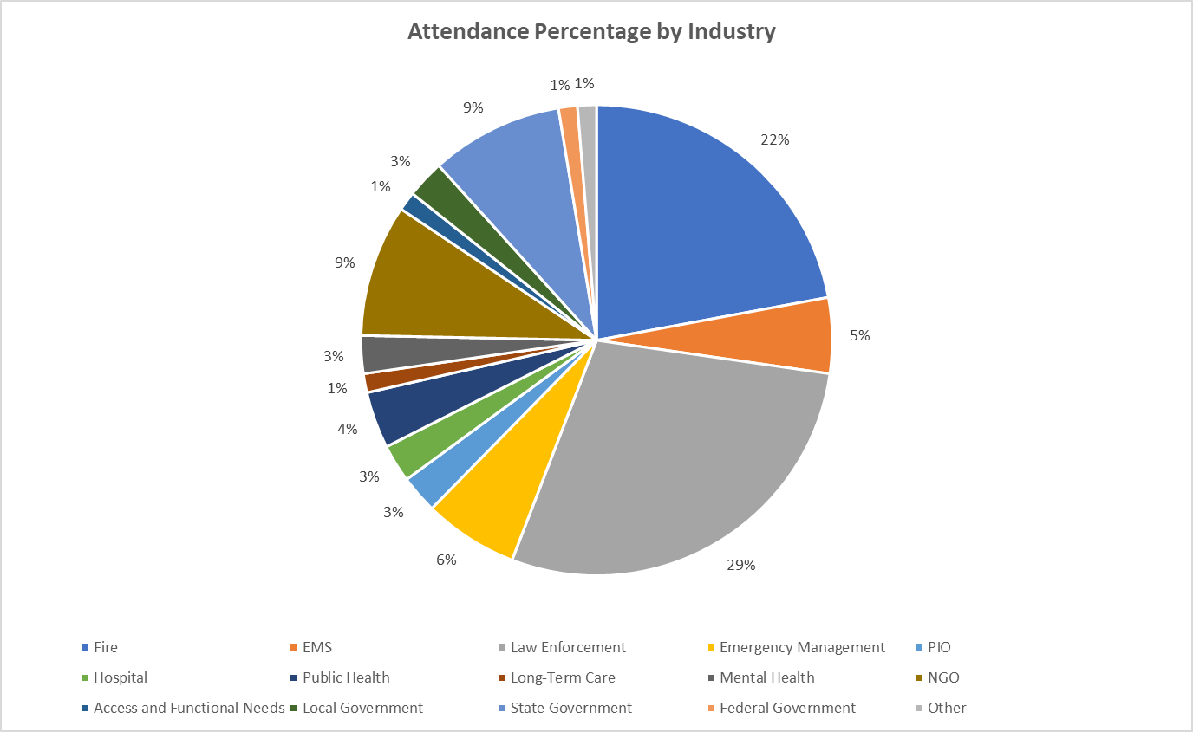

The top eight considerations derived from the event were the following:
- Determine how interoperable communication strategies (doesn’t have to be the same frequency for fire and law enforcement) will work prior to the next event.
- Review Unified Command practices and organizational chart, noting crucial and allied partners.
- Establish early alerts to hospitals as a protocol.
- Consider additional roadways (ingress/egress) ahead of an event – as viable – educating elected officials on the rationale.
- Explore the concept of a medical operations coordination center/Unified Hospital Command concept for hospitals (victims will find ways to reach the hospitals regardless of controlled perimeters). Ensure patient tracking (occurs between hospitals) to another to enable families to determine the final destination for victims/patients.
- Establish reunification/shelter practices among all partners and exercise them.
- Establish partnerships with all hospitals in the region to prepare for an MCI (the capacities for managing the disaster will tap all healthcare systems).
- Ensure access and functional needs partners are integrated into disaster exercises.

