Arizona Wildfire Targeted Event Readiness Forum (TERF) Executive Summary

The TERF was held on March 9, 2022, from 8:00AM to 3:00PM at the Desert Willow Conference Center (4340 E. Cotton Center Blvd, Phoenix, AZ 85040). A total of 122 attended the event. Attendance is displayed on the next page.

There were four main objectives that guided the event. By the end of this TERF, participants were anticipated to better be able to:
- Determine how planning will be implemented for:
- Relationship establishment among local, state, tribal, territorial, federal, and private sector entities (including integration of representatives from the Access and Functional Needs Population service arena into planning, identification of community evacuation roles and responsibilities, identification of small and big animal shelters, and identification of municipal/local Family Reunification Centers and shelters [feeding, security, and practices during COVID-19]).
- Training (including activation of Emergency Response Interpreter Credentialing program personnel and familiarization with available resources).
- Supply and equipment assessment, procurement, and contracts (including air and ground assets and water and effluent rights access).
- Determine how public information and warning will be implemented (including citizen notification of mass care services and Ready/Set/Go planning).
- Determine how mitigation activities will be implemented (including “Firewise outreach” and reduction of fuels, such as non-native species of grass and weeds)
- Determine how response will be activated and provided (including Declaration of Need, operational coordination, communications [including Wireless Emergency Alert System], unified command, rescue and evacuation (including recreational areas), and critical infrastructure systems).
Evaluations conducted during the event showed significant improvements on all objectives as a result of the event.

The following scenario was used to foster discussion among the participants: It is late June on a Friday at noon, and approximately 200 hikers are ascending or descending in the McDowell Mountains. Drought is persistent in the state, and the red brome grass is knee length and fully cured out. The evening before (Thursday night), a series of dry lightning bursts landed across the Valley, including the northeast part of Maricopa County. The heat has reached 115 degrees, wind gusts are at 20 miles per hour from the southwest, and the smoldering embers have sparked in parts of the McDowell Mountains. It is expected additional new starts are also “waking up” in the Northeast region of the county.

By 1:00PM, one of the fires has grown and is endangering multiple Scottsdale and Fountain Hills developments, including child cares and nursing homes. Furthermore, the fire is threatening Rio Verde, Carefree, Cave Creek, Tonto Hills, camp sites, major utility carriers, and other critical infrastructure.

Twenty-four hours later, the fire is expected to double in size with persistent hot dry windy conditions. Firefighting aircraft are mostly unavailable and committed in other geographic regions due to National Preparedness Level 5 (highest status).

Forty-hours later, more lightning is expected.

Seventy-two hours later and beyond, flooding and other consequences of the wildfire experienced.

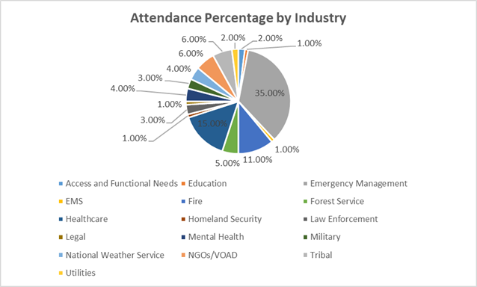

The top 10 considerations derived from the event were the following:
- More researchers and funding are needed to pursue effective wildfire mitigation strategies and tools. Insufficient information is currently available to help responders understand the shifts occurring in desert environments, including urban-forest interfaces.

- Explore the creation of wide buffers and increased mowing across Arizona roadways to decrease the likelihood of wildfire onset.

- Develop municipal/tribal checklists for wildfires. There may be a need for multiple lists to address different intervals of a fire response.

- Work with utility companies to understand the perils of fire/smoke tripping utility lines and thereby causing the loss of transmission, arcs, and other cascading events.

- Plan for protection of critical infrastructure, such as communication towers.

- Confirm equipment – such as needed aircraft – will be available and feasible (due to cost limitations) in all seasons. If there are competing interests, identify collaborative opportunities (purchase coops/other) to ensure the right type of equipment may be activated. Explore opportunities for work with the military on use of assets, such as infrared imagery capacities.

- Identify water sources/dipping sites ahead of time. Use of untreated water can be problematic. Viability assessments must be conducted and agreements must be secured.

- When drones are to used, be sure to purchase a) the equipment that is appropriate for the application and b) software that is meant to be used with the equipment. Understand the legal issues, terrain coverage restrictions, litigation factors, the need to connect IT, policy issues, and best practices. Coconino County has extensive experience with drone research and may be a resource for determining optimal methods for selecting equipment and software.

- Identify optimal notification systems for diverse community needs (WEA, Rave Mobile Safety, Amber Alert, AzHAN, or other) and ensure the system selected is able to reach access and functional needs (AFN) populations. Train firefighters and law enforcement on the new ASL glossary and accommodations needed for AFN populations.

- Use EMPG funding to plan strategies with prisons, long-term care, hospitals, access and functional needs providers, schools, and other large facilities to:

- Clarify the roles of EMS (or absence of EMS) and law enforcement during evacuation.
- Identify and address communities/regions with single egress routes.
- Confirm pre-determined animal and human relocation sites and other disaster response plan elements are viable with leadership (schools, elected officials, vendors, and others) to ensure there are no conflicts when activation is needed.
- Assure AFN populations have the assistive technologies and wheel chairs they require to maintain independence (identify para-transport assets).
- Avoid plans to transport AFN populations to long-term care facilities and hospitals as such actions can congest facilities that may be needed as evacuation sites for other purposes and are not appropriate (example: developmentally disabled population behaviors may be exacerbated in hospital settings).
- Enable smaller long-term care facilities to understand evacuation site options.
Exercise these plans to avoid confusion during actual incidents.

