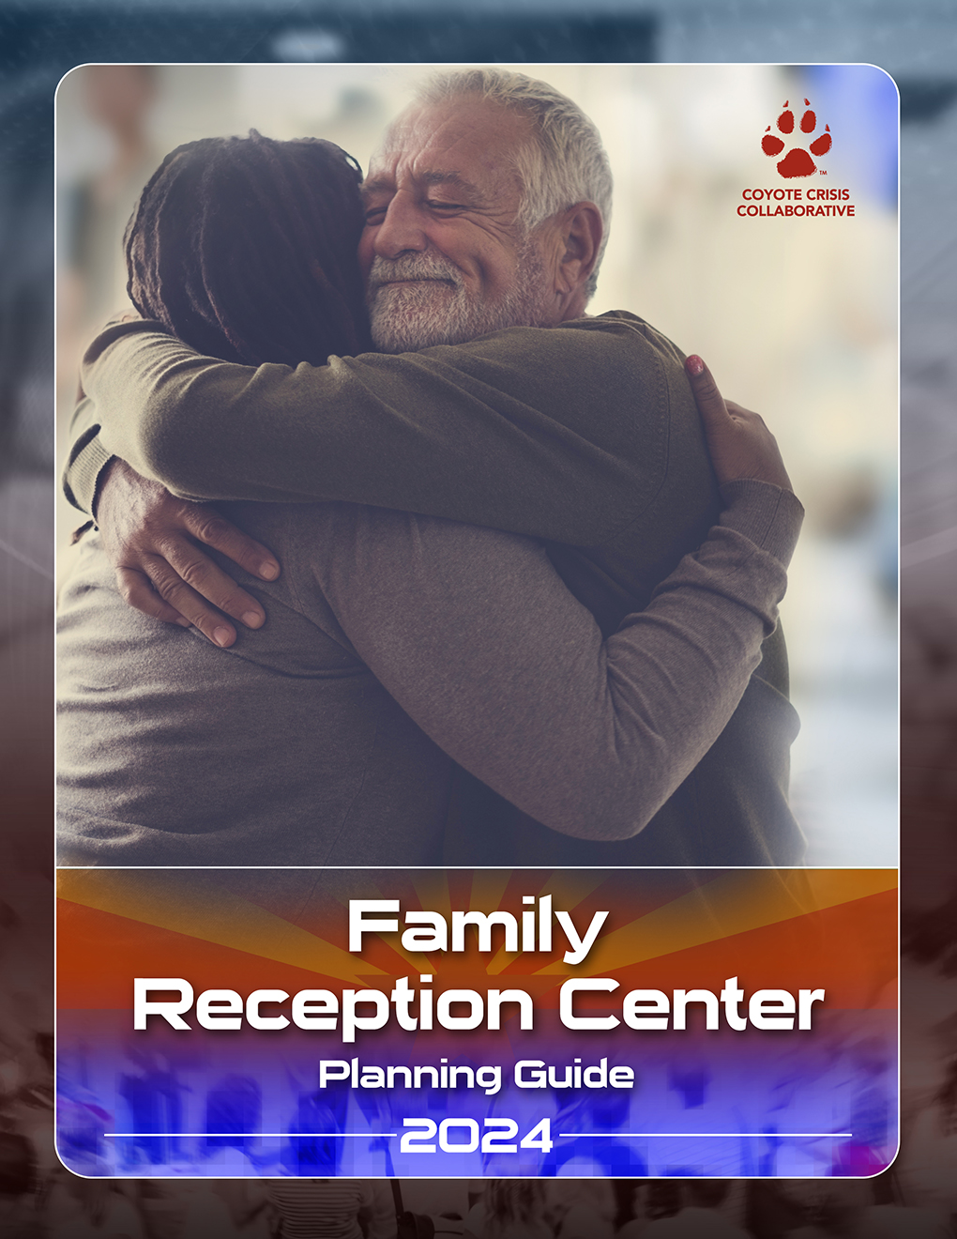

Thank You to the Following
Much of this Family Reception Center (FRC) Planning Guide was derived directly from the Tempe Reunification Plan and the Phoenix Reunification Plan.
In addition, thank you to the following individuals for participating in the FRC Work Group:
- Adam Costello, Emergency Services Planner, Maricopa County Department of Public Health (MCDPH),
- Cody Curl, Emergency Management and Disaster Preparedness Specialist, HonorHealth,
- Anne Dellos, CARES Team (Call Center) Supervisor, MCDPH
- Kim Gathers, Phoenix Emergency Management Coordinator,
- Jason Gillette, Assistant Director, Coyote Crisis Collaborative
- Michael Grassel, Emergency Management Coordinator, Maricopa County Department of Emergency Management,
- Stephanie Miller, Disability and Emergency Preparedness Equity Educator, Arizona Statewide Independent Living Council (AZSILC),
- Terry Nelson, Salt River Pima-Maricopa Indian Community Emergency Manager.
- Michelle Seitz, Emergency Manager, City of Tempe
- Katie Turnbow, Program Manager, Public Health, Organizational Support and Community Operations, MCDPH,
- Tonja Watston, Office of Preparedness Response, Planning Specialist, MCDPH,
- Martha Williams, Senior Social Services Coordinator, CARE 7 Crisis Response Units, and
- Deborah Roepke, Executive Director, Coyote Crisis Collaborative (Work Group Facilitator).

For additional information, contact:

Michael Grassel, Emergency Management Coordinator, Maricopa County Department of Emergency Management at 602-273-1411 or michael.grassel@maricopa.gov

Martha Williams, Senior Social Services Coordinator, CARE 7 Crisis Response Units, at 480.858.2106 or martha_williams@tempe.gov

Deborah Roepke, Executive Director of Coyote Crisis Collaborative, at 480.861.5722 or Deborah.Roepke@coyotecrisis.org

Table of Contents

Mission, Scope, and Planning Assumptions 4
Definitions 6
Incident Flowchart 9
Family Reception Center (FRC) Organizational Chart 10
Site Selection and Activation Procedures 11
FRC Roles and Responsibilities 13
Deactivation 18

Appendices

Job Action Sheets (A) 19
QR Code and Links to Family Reception and Family Registration Platforms (B) 24
FRC Supply List/Established Bins (C) 26
Sign In/Sign Out Sheet (D) 27
Back Up Forms/Paper Copies (E) 28
Call Center Survey (F) 29

Family Reception Center Planning Guide
Mission: To provide a planning guide to assist municipal and tribal partners – within Maricopa County – in setting up a Family Reception Center (FRC) following a major incident. For this Planning Guide, a “major incident” will not be defined as every jurisdiction will have their own set of “trigger points” that must be considered.
Scope:
- Provide accurate, accessible, and timely information to the family and friends of victims regarding the incident in a private and secure environment.
- Provide a mechanism to coordinate efforts between emergency management, law enforcement, EMS, hospital, call center, and medical examiner personnel to facilitate identification of victim status and client notifications to family and friends.
- Provide emotional support and spiritual care services to family and friends.
- Protect families from the media and curiosity seekers.
- Provide a childcare safe zone for unaccompanied minors.
- Organize family reception and reunification for family and friends.
- Support death notifications to next of kin for victims that have died when identity is known.

Planning Assumptions:
- Expect a minimum of eight to ten family members or loved ones per victim to arrive at the FRC, call the call center, or request assistance.
- After an incident, family members may immediately call or self- report to the hospital they believe their loved one may have been taken.
- Coordination among responding agencies about family members, missing persons, and victim tracking will be necessary.
- An FRC will be necessary to provide a safe place for families to convene until a Family Assistance Center or shelter is activated.
- Families will have high expectations regarding:
- Identification of the deceased,
- The return of loved ones and their belongings,
- Accurate and timely information and updates.
- Victim identification may take multiple days, weeks, months or even years.
- There may be communications barriers for those with access and functional needs arriving at the FRC.
- Not all families will grieve or process information in the same way.
- Ethnic and cultural traditions will be important factors in the way families grieve or process information.
- Both Behavioral Health and Spiritual Care resources should be available.
- Responding to a mass casualty or mass fatality incident can be overwhelming and lead to traumatic stress. Support for staff will be essential.
- A specific safe zone must be established for unaccompanied minors to ensure appropriate release to a custodial adult.

Definitions Used by All Family Reception Initiative Partners
Reunification | The process of reuniting family members with their missing or deceased loved one.
Emergency Call Center | Following a mass casualty or mass fatality incident, this designated space is activated as a communications hub to collect information from families and friends of possible victims (integrates Medical Examiner/Coroner interviews); to direct families and friends to appropriate Hospital Reception Sites, Family Reception Centers, or Family Assistance Centers for reunification and assistance; and to direct other callers to appropriate recipients, such as Public Information Officers.
Family Assistance Center  (Long-Term) | Following a large mass casualty or mass fatality incident, this designated municipality, county, tribe, or state space is established as a centralized location for families, friends, and survivors to gather, receive information about the victims and grieve, protect families from the media and curiosity seekers, facilitate information sharing to support family reunification (e.g., direct families to Hospital Reception Sites if victims are known to have been transported to the location), and provide death notification when patients die and identity is known. This Center is long-term and may target delivery of a range of services and/or may focus on families and friends of missing or deceased victims.
Family Reception Center  (Short-Term) | In the immediate hours after a mass casualty or mass fatality incident, this designated community space is established as a centralized location for families (and friends) to gather, receive information about the victims and grieve, protect families from the media and curiosity seekers, facilitate information sharing to support family reunification (e.g., direct families to Hospital Reception Sites if victims are known to have been transported to the location), and provide death notification when patients die and identity is known. This Center is short-term and may be replaced by a Family Assistance Center or shelter in the event the municipality, county, tribe, or state deems this to be necessary. The duration is generally 12 to 24 hours but can last as long as three days.
Hospital Reception Site | A hospital space designated to provide a private and secure place for families to gather, receive information about the patients and grieve, protect families from the media and curiosity seekers, facilitate information sharing with other hospitals and partners to support family reunification (e.g., direct families to Family Reception Centers if victims are missing), and provide death notification when patients die, and identity is known.
Family | Any individuals that consider themselves to be a part of the victim’s family, even if there is not a legal familial relationship. This could include friends, partners, caregivers, and loved ones that have defined themselves or are indicated by other family members to be “family”.
Immediate Family | A defined group of relations, used in rules or laws to determine which members of a person's family are affected by those rules. It normally includes a person's parents, spouses, siblings, and children.
Custodial Parent | The parent that is also considered the primary care parent with which a child resides full time. Most custodial parents have been awarded physical custody of a child by a court of law.
Legal Guardian | A person or entity who has been granted the legal authority (and the corresponding duty) to care for the personal and property interests of another person, called a ward.
Legal Next of Kin | The nearest blood relatives of a person who has died, including the surviving spouse.
Separated Children | Children who have been separated from both parents or from their previous legal or customary primary caregiver, but not necessarily from other relatives. These may, therefore, include children accompanied by other adult family members.
Unaccompanied Minors | Children who have been separated from both parents, legal guardians, and other relatives and are not being cared for by an adult who, by law or custom, is responsible for doing so (18 or under).
Access and Functional Needs Populations (AFN) | People with and without disabilities who have physical, programmatic, and effective communication accessibility requirements before, during, and after an incident. Areas include, but are not limited to maintaining independence, communication, transportation, safety and self-sufficiency, and medical care. Individuals with access and functional needs include, but are not limited to, those who have disabilities; those live in institutionalized settings; older adults; pregnant women; children; those from diverse cultures; those who are non-English proficient and/or have low literacy; those who are transportation disadvantaged; and those recovering from temporary illness or surgery.
Accessible Emergency Public Information | Information may be disseminated to AFN populations through use of interpreters, public address systems, closed-captioned television, door-to-door notifications, Braille, etc. Certain populations may have limited access to internet, radio, news, or media reports including, but not limited to AFN populations, rural populations, and outdoor and seasonal workers who may also be exposed to threats or incidents in a more immediate fashion.

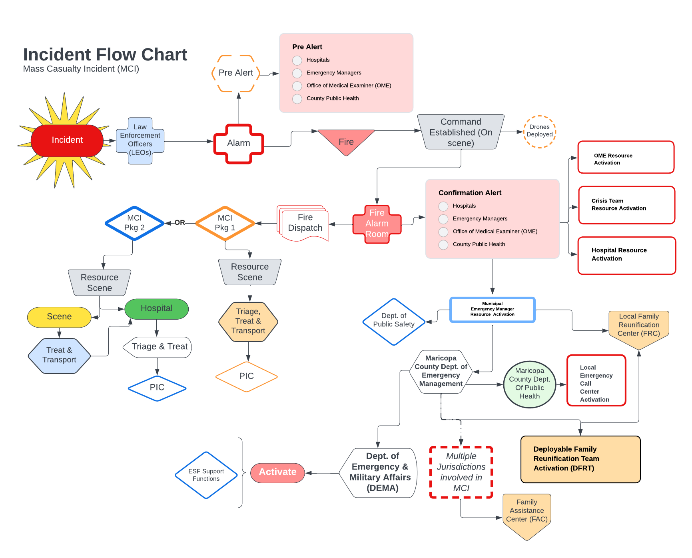
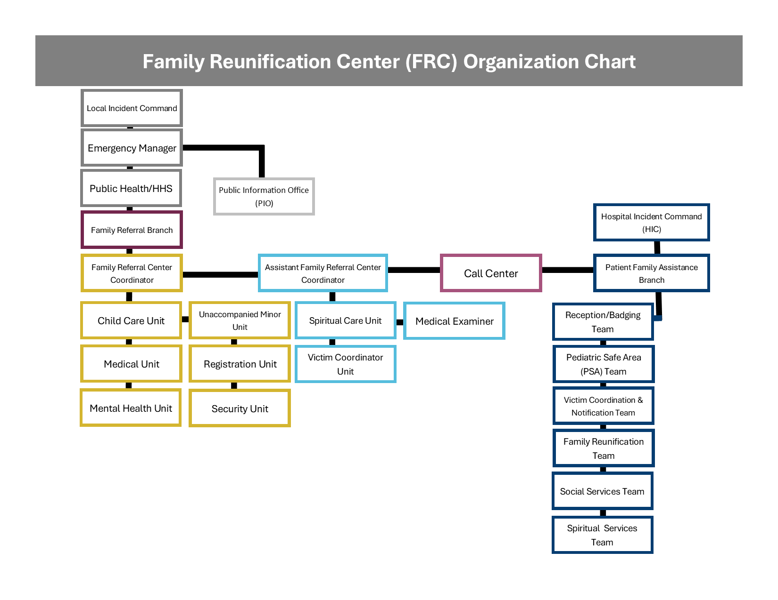
Site Selection

Consider working with a library, community center, or Red Cross-approved venue when determining an optimal venue for an FRC. The following list is offered for consideration when selecting the FRC location. This site must be secured to ensure the privacy of those receiving services at the site.

There may be an incident in which a faith-based site is self-determined by families and friends. Under these circumstances, the FRC and OME may need to assign someone to communicate via phone or another protected communication device with a leader from the synagogue, church, or other faith-based venue.

Site Accessibility Criteria:

- Easy access from major roads, freeways, or public transit.
- Close proximity to individuals and clients affected by the incident.
- Proximity to mass transportation resources.
- Adequate number of parking spaces, including accessible parking spaces.
- Parking lot layout that is amenable to law enforcement access restriction.
- ADA compliance/accessibility to AFN populations.
- Availability on short notice.
- Large indoor space to accommodate multiple work/resource stations.
- Small area for a quiet space.
- Proximity to restrooms, water sources, and a security station.
- Controlled heating/air conditioning.
- Accommodations for all FRC positions and needs, including the Child Care Unit.
- Appropriate space for the Office of the Medical Examiners (OME), including the following (work with the OME to ensure needs are met).
- Ability to support communications and technological infrastructure, including expected power load and data transmission capability.
- Approval from a safety officer (prior inspection) on the capacity to ensure the safety of all staff, family, and friends (no hazards, including cable or other wiring) and ADA Compliance/accessibility to AFN populations.

Activation Procedures

FRC Activation. The following bullet points outline the FRC Activation Procedure:
- The municipal/tribal emergency manager will be notified by a regional dispatch center of an MCI (early and confirmation notifications).
- After notification of the municipal/tribal reunification coordinator, the municipal/tribal emergency manager will contact the Maricopa County Department of Emergency Management (MCDEM) Duty Officer at 602.273.1477 to advise of Emergency Operations Center (EOC) Activation.
- The municipal/tribal emergency manager will provide MCDEM with the municipal/tribal reunification coordinator contact information and FRC location for activation of the Deployable Reunification Team.
- The municipal/tribal emergency manager will contact the MCDEM to activate the Call Center to assist the public with completion of the MCTRAC victim tracking information and images.
- The municipal/tribal emergency manager will notify the Emergency Call Center with information regarding the FRC which can be communicated to the public.
- Upon notification from the dispatch center, the municipal/tribal emergency manager will contact the municipal/tribal reunification coordinator to initiate the activation of the FRC.
- Upon notification from the municipal/tribal emergency manager, the municipal/tribal reunification coordinator will notify the municipal/tribal reunification team comprised of employees using the current alert/notification system if possible. If there are insufficient staff to support the FRC, consider activating a Regional Deployable FRC Team (see below).
- The municipal/tribal reunification team will respond to the designated FRC.
- The municipal/tribal emergency manager will activate the Joint Information Center (JIC).

MCI Call Center: The MCI Call Center Plan supports the MCTRAC collaborative effort to prepare for future mass casualty incidents.

Should there be a mass casualty incident in Maricopa County, the primary responding agency can request the activation of a call center through the Maricopa County Department of Emergency Management (MCDEM). It will be the responsibility of MCDEM to determine if the current situation warrants the activation of the MCI Call Center.

After MCDEM notifies the on-call Duty Officer or designated individual that the MCI Call Center needs to be activated, Office of Preparedness and Response (OPR) leadership will determine the response level needed. The Duty Officer will then notify the CARES Call Center Supervisor and the Medical Reserve Corp (MRC) Supervisor if volunteers will be required to begin the activation process.

During the response the MCDPH MCI Call Center purpose is to:
- Alleviate call surges on hospitals and 911 dispatch centers.
- Provide accurate and timely information to family and friends of victims.
- Direct any other inquiries (e.g., media) to the appropriate resources.
- When requested, collect data for critical organizations via MCTRAC.

Regional Deployable Reunification Team Activation. The Regional Deployable Reunification Team activation follows identical processes listed for FRC activation 1. through 5. above. The following bullet points outline the unique and/or other activation procedures:

- The municipal/tribal emergency manager will provide MCDEM with the Local Reunification Coordinator contact information and FRC location for activation of the Deployable Reunification Team.
- The municipal/tribal emergency manager will request that MCDEM activate the Deployable Reunification Team using the current alert/notification system.

The deployable team will respond to the FRC to supplement services and provide resources. The deployable team consists of:
- Red Cross,
- Arizona Counter Terrorism Information Center (ACTIC) Facial Recognition Team,
- Department of Child Safety,
- Crisis Teams, and
- Office of the Medical Examiner.

Additional considerations dependent on incident:

- Family Host Unit,
- Technology/Communication Support,
- A financial donations plan and ability to accept donations at or near the FRC,
- School Liaison,
- Hospital Liaison,
- Business Liaison,
- FBI Victim Services (must be requested by a police department),
- Humane Society/Animal Services, and/or
- Voluntary Organizations Active in Disaster/Community Organizations Active in Disaster

Additional Comment: Due to the size of the jurisdiction, some positions may need to be combined and filled by one person.

FRC Position Roles & Responsibilities

Municipal/Tribal FRC Coordinator (This is a critical role, but the Coordinator can assume additional roles as needed):
- Oversees FRC Operations.
- Coordinates with municipal/tribal EOC Emergency Manager.
- Determines staffing levels of the FRC, requesting resources as needed.
- Deploys local/tribal resources.
- Delegates staff assignments and facilitates Just In Time (JIT) trainings.
- Serves as the point of contact for the Regional Deployable Reunification Team.
- Serves as the point of contact for the Call Center.

Internal Security Unit (This is a critical role, but can be merged with the External Security Unit indicated below):

Appoint interior security personnel to include:

Fixed Security Posts,

Roving Patrol Officer,

Reception Desk/Check-In.

Prevent unauthorized access to all building entrances and exits.
- Verify site is safe and usable.
- All authorized persons seeking admittance into the site are subject to a cursory weapons search by law enforcement personnel.
- Oversee and enforce badging/identification for family and staff.
- Provide security presence to all family briefings.
- Escort non-badged personnel who are authorized to temporarily be on site (i.e., vendor, maintenance, or delivery personnel).
- Immediately address any potential threats to site operations and the safety of those located therein.
- Address and document incidents that occur on site.

External Security Unit (May be merged with Internal Security Unit):

- Establish and enforce FRC perimeter security.
- Prescreen individuals as they approach the perimeter entrance of the site.
- Direct media personnel to the appropriate location identified for media.
- Ensure that only official vehicles assigned to staff at the FRC, as well as vehicles operated by families, are granted access to the restricted area.
- Expedite vehicular traffic outside restricted areas.
- Immediately address any potential threats to site operations and the safety of those located therein.

Registration Unit (This is a critical role for flow into the FRC and can be enhanced by security guards; at least two individuals should be positioned at the registration desk):

- Oversee all registration activities, families and FRC staff.
- Ensure all forms (QR or paper forms) are properly completed by families registering at the FRC.
- Ensure family members are provided with wrist bands at entry.
- Maintain a current roster of families and staff at the FRC.
- Identify unaccompanied minors and ensure connection to a law enforcement officer and the Child Care Unit.
- Coordinate with security and law enforcement to ensure only authorized individuals are granted access to the FRC.
- Coordinate with security and law enforcement to ensure all staff and families are properly credentialed.

Family Host Unit (This is a non-essential Unit, but it offers a good bridge from the Registration Unit to other Units if staffing permits):
- Greet family members upon entry into the FRC/Staff the family entrance area.
- Answer questions concerning services and procedures.
- Provide a brief orientation and tour of the FRC facility if possible.
- Ensure families have the appropriate supplies and resources (chairs, tables, tissues, facility map, charging areas, and more).
- Provide assistance to AFN populations.

Family Briefing Unit (This is a critical Unit requiring at least two team members):

- Coordinate all family briefings, ensuring they are accessible to those with access and functional needs.
- Coordinate all key stakeholders for family briefings to gather information and/or speak (PIO, LEO, Fire, EMS, Interpreters, American Sign Language [ASL] and CART services [refer to information below on CART], and others as necessary).
- Coordinate information with families not at the FRC (virtual if necessary) using the QR codes/links provided to those who have registered victims through the Mass Casualty Tracking and Reunification Collaborative (MCTRAC) system.
- Ensure AFN considerations in communication, including CART services, ASL interpretation, and any other approved system for communicating with those who have AFN.
- Answer all family questions/concerns possible in family briefings.
- Coordinate all family messaging with the JIC ensuring families are provided briefings prior to any press conferences.
- Communicate any family concerns to the municipal/tribal FRC coordinator.

Note: ASL interpreters and Communication Access Real-time Translation (CART) service providers (also called open captioning, real-time stenography, or real-time captioning) will support public meetings, media briefings, one-on-one public interactions in shelter operations, and informational videos. Effective August 3, 2018, Arizona government entities at the municipal, county and state level are required, per A.R.S. § 9-500.44, A.R.S. § 11-269.25, and A.R.S. § 41-5202, to ensure that communications with persons with disabilities, including online communications and emergency communications, are equally as effective as communications with persons without disabilities pursuant to the Americans with Disabilities Act. ASL interpreters and CART providers in the state of Arizona have been specially trained in Emergency Management by the State of Arizona and Maricopa County and credentialed via the Emergency Response Interpreter Credentialing (ERIC) Program to provide services to public agencies during times of disaster. Credentialed ASL interpreters and credentialed CART services providers may be requested through an Incident Command System (ICS) Form 213-RR to Arizona Department of Emergency and Military Affairs.

Briefing Examples:

Opening Briefing:
- Safety orientation.
- Restrooms.
- Evacuation instructions.
- Introduction to the speaker.
- Schedule for briefings.

General Briefing:
- Recap of critical information.
- Status of rescue/recovery operations.
- Status of identification process.
- Assistance update with the FRC (crisis counseling, childcare, etc.).
- Status update regarding timeline for FAC transition.

Child Care Unit (This is a critical Unit, but can be filled by trained support staff overseen by the Mental Health Unit; there should be adult for each eight children):
- Oversee the provision of childcare at the FRC.
- Continually assess the childcare needs of families at the FRC.
- Ensure the safety of children under the care of childcare providers at the FRC.
- Alert and maintain contact with the Department of Child Safety (DCS).
- Maintain constant supervision of unaccompanied minors as DCS/law enforcement is notified.

Unaccompanied Minor: The DCS Child Abuse Hotline (1-888-767-2445) can accept communications regarding situations where a parent is unavailable and cannot be reached in order to take custody of their child, or the parent can be reached but does not have the immediate resources to take custody of their child. In the event of a mass casualty incident, and a parent is unavailable, incapacitated, or deceased, then exigent circumstances would exist for DCS to take a child into temporary custody because such a child would be at imminent risk of abandonment.
When the DCS Child Abuse Hotline receives communications from the FRC, they will inquire about the family composition, if and how any of the child’s family members can be located, and whether there are any indications of suspected abuse or neglect, in addition to the presenting problem that the child has no current caregiver. Once the Hotline accepts the report, a DCS investigator will contact the FRC and arrange to see the child there (ideally there would be a private space for DCS to interview the child and other sources).

DCS staff shall determine if there is any action the Department can take, including exploring options other than placing the child in Department custody; this may include efforts to locate a relative or fictive kin (defined as caregivers who are considered part of the family even though they are not related by blood or marriage) who can provide living arrangements for the child. If DCS determines that taking a child into the Department’s custody is warranted, a Notice of Removal shall be provided to the responsible authorities at the FRC, and DCS shall follow all established state child welfare policies and services if more long-term arrangements such as placement in a shelter or foster home are deemed necessary.

Victim Coordination Unit (This is a critical Unit, but can be enhanced by ACTIC; at least two team members are required to staff this):
- Access the back end of JotForm (refer to Appendix for QR Code), for the purpose of sorting records.
- Conduct preliminary matching and locating victims who were transported to local hospitals.
- Coordinate with hospitals to confirm patient whereabouts (should be done with the hospital liaison).
- Provide individual updates to families in the FRC, when victims can be positively identified and located.

Mental Health Unit (This is a critical Unit, but the Unit can take on Family Host duties as needed):
- Provide psychological triage and conduct informal risk assessments of families and FRC staff.
- Provide Psychological First Aid (PFA) including psych education, referrals, and advocacy.
- Assist with provision of crisis intervention/mental health care.
- Ensure the privacy and confidentiality of all verbal and written mental health interaction and documentation concerning families.
- Ensure proper nutrition, water intake, rest, and stress management.
- Observe staff and volunteers for signs of stress.
Medical Unit (This is a critical Unit requiring at least one qualified staff member):
- Coordinate and provide basic health services and first aid to all FRC families.
- Provide referrals to outside medical or pharmaceutical services as necessary.
- Continually assess the medical first aid needs of the families at the FRC.
- Ensure the privacy, confidentiality, and security of all protected health information.

Deactivation of FRC/Transition to Family Assistance Center (FAC)

The FRC is a transitory step towards a Family Assistance Center (FAC). A FAC is a larger location which is opened to deliver survivors and families a wider range of services and support for a longer term. The FAC preparation will begin once the FRC has been initiated. The FAC should be opened within 72 hours of the mass casualty or mass fatality incident. The FAC model is situational, scalable, and needs-focused.
The FAC is a critical piece in the support provided to family members. Responding agencies must remain sensitive to the needs of the family members and injured victims and adjust their response plans accordingly.

The deactivation of the municipal/tribal FRC transition to an FAC will be coordinated and handled by the municipal/tribal Emergency Operations Center (EOC) and will be based on FRC status updates and operational needs. The transition will proceed as follows:
- Unless the jurisdiction is unincorporated, the municipal/tribal FRC transition to an FAC is the responsibility of the jurisdiction. The municipality/tribe is responsible for activation and staffing the FAC as well.
- A collaborative decision about when to transition the FRC to the FAC will be determined between the tribal/municipal Incident Commander, the tribal/municipal emergency manager, the Chief Medical Examiner, and the MCDPH (as relevant).
- The Director of the FAC will coordinate the activation of the FAC based on the number of fatalities and serious injuries, the impact to the community (localized or widespread), type of needs, and availability of services.
- The FRC staff will make family members aware of the FAC location to meet their needs more effectively if the FAC is a different location than the FRC.
Once the FAC is activated, the municipal/tribal FRC will be demobilized.
Appendix A: Job Action Sheets

Municipal/Tribal FRC Coordinator:
Upon receiving a confirmation alert from the municipal/tribal emergency manager, initiate alert to internal employees who will staff the FRC.
Respond to the FRC.
Monitor alert replies to determine available staff.
Confirm chain of command is aware.
Ensure sufficient number of supply kits are on site.
Create an FRC staff check-in desk at the staff entrance of the FRC.
Supplies needed:
- Sign-in sheets.
- Wristbands for FRC staff.
- Job Action Sheets.
Assign roles to personnel as they arrive for FRC duties, prioritizing check-in/JIT training/room set-up.
Conduct initial briefing of situation.
Ask police, sheriff, or DPS to request FBI Victim Services.

Internal Security Unit:
Secure entrances.
Lock/enable public elevators to allow for lower-level access, not second floor access, as needed (depending on FRC site).
Appoint interior security personnel to:
- Staff check-in desk.
- Family reception/check-in desk at main entrance.
- Briefing room during scheduled briefings.
- Fixed security posts.
- Roving patrol officer(s).
Once the FRC is opened to families/receiving families:
- Conduct cursory weapons search of persons entering the FRC.
- Oversee and enforce badging/identification for family and staff.
- Escort non-badged personnel who are authorized to temporarily be on site (i.e., vendor, maintenance, or delivery personnel).
- Immediately address any potential threats to site operations and the safety of those located therein.
External Security Unit:
Establish and enforce FRC perimeter security.
Appoint exterior security personnel to:
- Staff entrance(s).
- Serve as roving patrol officers.
Once the FRC is open to families and receiving families:
- Prescreen individuals as they approach the perimeter entrance of the site.
- Redirect media/non-authorized personnel to appropriate location for the media.
- Redirect those wishing to donate goods or money.
- Ensure that only official vehicles, FRC/EOC staff vehicles, and family vehicles are granted access to the lots.
- Expedite vehicular traffic outside restricted areas.
- Immediately address any potential threats to site operations and the safety of those located therein.

Registration Unit:
Create an accessible FRC registration space using existing tables/furniture.
Position and coordinate with Security to monitor use of the main entrance, stairwell, and elevators (as needed)
Supplies needed:
- Devices for registration.
- Charging cords/extension cords.
- QR codes and back-up forms from FRC kit.
- Wristbands.
- FRC maps and welcome flyer.
- Access and functional needs considerations.
Once the FRC is opened to families/receiving families:
- Ensure all forms (QR or paper forms) are properly completed by families registering at the FRC.
- Ensure all family members provide a form of identification when entering/reentering the FRC.
- Ensure all family members are wrist banded at the time of entry.
- Provide families with accessible FRC maps and welcome fliers.
- Assist with any access and functional needs.
- Identify unaccompanied minors and ensure connection to law enforcement and Child Care Units.
- Transition families to Family Host Unit when available.
- Coordinate with security and law enforcement to ensure all family members are properly credentialed.

Family Host Unit (once the FRC is opened to families):
Greet family members upon entry into the FRC/be available in the family entrance area
Escort families to the computer stations, as required for registration, social media searching, ensuring access and functional needs are met.
Answer questions concerning FRC services, resources, and procedures.
Provide a brief orientation and tour of the FRC facility if possible.
Ensure families have the appropriate supplies and resources (chairs, tables, tissues, facility map, charging areas, and assistance for access and functional needs, and more as needed).
Recap of critical information, if possible.
Monitor family members for escalated behavior, connect to Mental Health Unit as needed.
Provide assistance to AFN populations. Assistance can include but is not limited to:
- Reading pamphlets or downloading a digital pamphlet to a person’s device.
- Providing tablets for temporary use.
- Reading/filling out forms and taking pictures for the forms.
- Providing ASL or other language interpretation.
- Providing CART Services.
- Physically guiding persons through the facility.
- Providing portable FM (frequency) listening systems for public briefings, if possible. These are unnecessary when CART services are available.

Family Briefing Unit:
Determine initial briefing schedule (e.g., 15 minutes, 30 minutes, or other).
Post briefing schedule in multiple locations:
- Registration desk.
- Outside of briefing room.
- Available whiteboards/signs in public areas of the FRC.
Establish contact with key stakeholders.
Ensure working technology for media viewing, streaming news coverage.
Coordinate all family messaging with JIC.
Ensure ADA compliance/AFN considerations for communications, including translation services.
Consider coordinating information with families not at the FRC (via email, if necessary). Consider platform and QR codes/link provided to those who have registered victim through MCTRAC system.
Once the FRC is opened to families/receiving families:
- Conduct introductions to the speaker/stakeholder(s).
- Conduct courtesy reminder about privacy/not recording FRC activities.
- Conduct recap of critical information.
- Provide status of rescue/recovery operations.
- Conduct status briefing on the identification process.
- Assist with update on FRC (crisis counseling, childcare, and so forth).
- Offer updates on the timeline for transition to an FAC.

Victim Coordination Unit:
Report to the municipal/tribal EOC for just-in-time JotForm training.
Establish contact with hospital case managers and ACTIC.
Access the back end of JotForm for the purpose of sorting records, preliminary matching, and locating victims who were transported to local hospitals.
Supplies needed:
- Devices for accessing platform.
- Charging cords/extension cords.
Coordinate with hospital case managers to confirm patient whereabouts.
Coordinate with additional FRC units as needed to provide individual updates to families in the FRC, when victims can be positively identified and located.

Mental Health Unit (once the FRC is open to families):
Continuously monitor families and friends to address ongoing needs.
Provide psychological triage and conduct informal risk assessments of families and FRC staff.
Provide Psychological First Aid (PFA) including psych. Education, referrals, and advocacy.
Assist with provision of crisis intervention/mental health care.
Assist the Victim Coordination Unit regarding individual updates to families in the FRC, when victims can be positively identified and located.
Ensure the privacy and confidentiality of all verbal and written mental health interaction and documentation concerning families.
Observe staff and volunteers for signs of stress.
Coordinate care when necessary to ensure the safety and well-being of families and FRC staff.

Medical Unit:
Establish a patient care area on the ground floor of the FRC
Once the FRC is opened to families/receiving families:
- Coordinate and provide basic health services and first aid to all FRC families.
- Provide necessary treatment and EMS transportation, if needed, to higher levels of care for further evaluation.
- Continually assess the medical first aid needs of the families at the FRC.
- Ensure the privacy confidentiality and security of all protected health information.

Child Care Unit (once the FRC is opened to families):
Report to the childcare area.
Oversee the provision of childcare at the FRC.
Continually assess the childcare needs of families at the FRC.
Alert and maintain contact with DCS.
Maintain constant supervision of unaccompanied minors as DCS/law enforcement is notified.
Deescalate and stabilize crises, provide children with basic coping tools.
Monitor children for escalated behavior, connecting to a Youth Specialist as needed.
Contact DCS in the case of an unaccompanied minor when no relative can be identified.

Appendix B: QR Code and Links to Family Tracking and Family Registration Platforms

Family Tracking: For families/friends to upload information about their missing loved one: https://hipaa.jotform.com/230178680511150

Family Reception Center Registration: For registration of family/friends upon arrival at the FRC: https://form.jotform.com/231205121420030

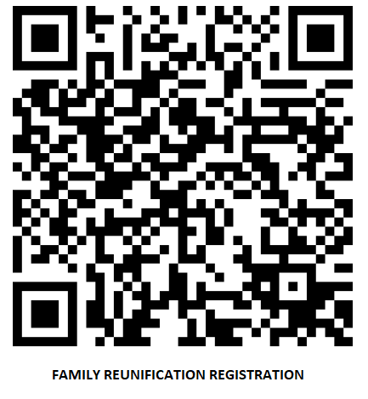

Evacuee Registration Form: For use when families are evacuated and in need of services as a result of a natural or man-made disaster: https://form.jotform.com/231217056813046

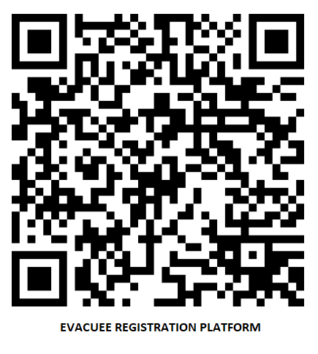

Appendix C: FRC Supply List/Established Bins

- General office supplies.
- Wristbands (Two different colors for staff/families).
- Locking file folder.
- Paper copies:
  - Sign in/sign out sheets for staff,
  - Family registration sheets,
  - Donation site flyers,
  - FRC maps,
  - Family Welcome Flyer, and
  - Job Action Sheets.
  - Accessible information in large print.
- Whiteboard arrows/signage.
- Dry erase markers.
- Chairs and tables.
- Maintenance supplies.
- First aid supplies with medical unit.
- Phone chargers for client use/phone charging station.
- Kleenex.
- Blankets.
- Radio charger/dock.
- Extension cords.
- Cases of water.
- Gloves.
- Clorox wipes.
- Evidence bags.
- Masks.
- Hand sanitizers.
- Access and functional needs considerations.

Appendix D: Sign In/Sign Out Sheet

Daily FAC Staff Sign In / Out Sheet |  |  |  |  | Date ___/___/_____ | Page 1 of 1
# | Last Name | First Name | Agency | FAC Assignment | Phone Number | Time In | Time Out

Appendix E: Back Up Forms/Paper Copies

Family Registration Form
Date
Primary Contact | Last Name |  | First Name |  | Middle Initial
Home Address
Email
Family Member(s) Sought (Victim(s))
Primary Phone Number | Type: □ Home □ Work □ Cell □ Text Messages Okay
Alternate Phone Number | Type: □ Home □ Work □ Cell □ Text Messages Okay
Identification Verified By  [Print Name] |  | Agency |  | Phone Number
Would you like additional victim assistance services?
□ Mental Health □ Spiritual □ Religious □ Cultural
How many children under the age of 18 are with you? ____________
Do you have childcare needs that require assistance?
□ Yes □ No
Do you have childcare needs that require assistance? If yes, please describe.

Do you have a disability that requires assistance? If yes, please describe.
Are you under the age of 18 and without a parent, guardian, or caregiver?
May we have your permission to share your contact information with the Family Assistance Center
and Red Cross staff for additional support and assistance?
□ Yes □ No

This form must be translated into Spanish.
Appendix F: Call Center Survey

