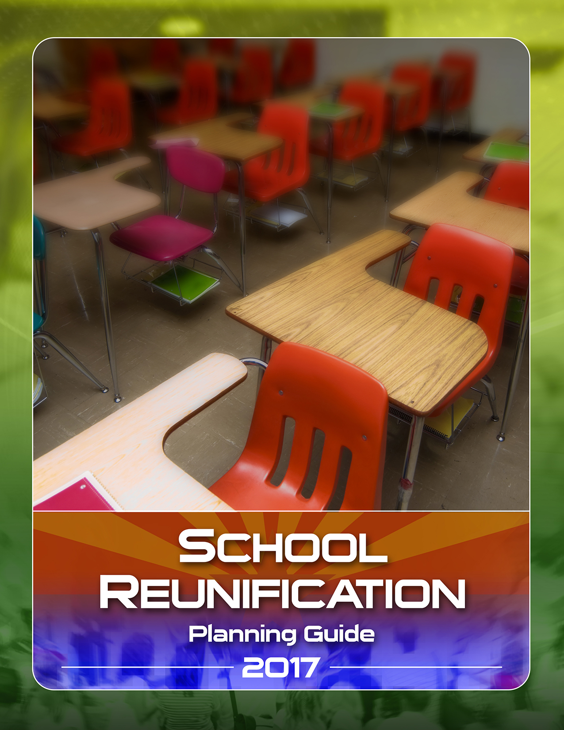

Thank you

Much of this Guide was derived from the Scottsdale Unified School District and the ASU/Coyote Crisis Collaborative Family Reunification Initiative. We are grateful for these models and indebted to James Dorer for his work.

For additional information, contact:

James Dorer at JDorer@susd.org

Jim Lee at Jim.Lee@azed.gov

Linda Mason at Linda.Mason@azed.gov

Allen Clark at Allen.clark@asu.edu

Deborah Roepke at Deb.Roepke@coyotecrisis.org

School Reunification Planning Guide
Introduction:

Every day, millions of families throughout the United States entrust their children to the care of school officials, and following an abnormal circumstance at school, these families have an expectation that they will be reunified with their children. The School Reunification (SR) Planning Guide is designed to help K-12 school districts and school administrators build a plan that allows for the organized return of students to the appropriate family members or guardians. It provides tips, tools, and ideas to help administrators write a functional protocol for the controlled release of students. Although the planning guide offers processes, sample plans, checklists, and job summaries for a SR Plan, one plan will not fit all schools. Your plan will need to be customized for the size of your district and/or school response capabilities, support personnel, resources available, student population, school location and environment, and other unique features of your community. Furthermore, the plan should be flexible enough to make appropriate changes that are based on the circumstances of the incident.

Scope:
The SR Planning Guide offers tips, tools, and ideas to help schools build a plan for family reunification. A reunification plan is only one part of a school’s multi-hazard emergency response plan, and this document solely focuses on the reunification process for school officials. The reunification plan may be activated for both non-threatening life safety events and mass casualty events. It is not intended to outline other response functions, such as evacuation or lockdown, and it is not designed to replace the roles of law enforcement and fire departments.
Planning Assumptions:
The following planning assumptions were made when writing this guide:
- Schools officials already have, or are in the process of building, a multi-hazard emergency response plan that outlines other response functions such as evacuations, shelter-in-place, and lockdowns.
- School officials understand that they are the ones who are responsible for the overall welfare and safety of their students, and this responsibility cannot be transferred or otherwise given away.
- School officials are responsible for students until they are formally released to authorized parents/guardians.
- School officials are responsible to account for visitors, including parents, when they are on campus for school related events.
- Schools and school districts may substantially differ in size, funding, and available resources.
- School officials work in conjunction with other local, county, and state agencies when planning for, responding to, and recovering from emergencies. It is assumed that school officials will partner with these agencies when creating their reunification plan.
- School officials are familiar with the general principles of the Incident Command System (ICS).
- When using the term “parents,” this planning guide includes parents, guardians, or others that are authorized for the care of the student.
Following a mass-casualty event, there are certain expectations for which planning should encompass. These expectations are derived from past large-scale incidents where reunification was required:
- Expect a minimum of eight to ten family members or loved ones to arrive or need assistance for each victim.
- Coordination among responding agencies about family members, missing persons, and patient tracking will be necessary.
- An SR will be necessary to provide a safe place for families to convene until a Family Assistance Center or shelter is activated, if this is needed.
- Families will have high expectations regarding:
- Accurate and timely information and updates,
- The return of loved ones and their belongings, and
- Identification of the deceased.
- A well-organized and easy to follow school reunification process.
- In the event of mass casualties, victim identification may take multiple days or weeks.
- Not all families will grieve or process information in the same way.
- Ethnic and cultural traditions will be important factors in the way families grieve or process information.
- Both Behavioral/Mental Health resources should be available.
- Responding to a mass casualty or mass fatality incident can be overwhelming and lead to traumatic stress. Support for staff will be essential.
- A specific safe zone must be established for unaccompanied minors to ensure appropriate release to a custodial adult.

Planning Guide Elements
When building a reunification plan, there are a few key concepts that should be included: every plan should focus on the safety and accountability of students and staff at all times. The plan should include a secure area for the care of the students while waiting for release, and it should be designed to allow for an orderly and managed return of students to the authorized parents/guardians.

This Planning Guide is broken down into four categories: places, people, supplies, and processes. Each area has associated checklists that may be found in the attachments to help you think through the optimal strategy for your school or district. How you choose to implement a plan is dependent upon the size of your district and/or school response capabilities, support personnel, resources available, student population, school location and environment, and other unique features of your community. The ideas and options presented in this planning guide are not all encompassing and are intended to provide a starting point for building a plan.
Places: Where Will Reunification Occur?

Reunification may occur on your campus, or students may need to be moved to an off-site location. The nature and scope of the incident will determine the needs for one or both.

On-site reunification is designed to reunify students with families while tracking student releases. This type of reunification may be used when students are staying on campus but parents are picking them up early or when a school needs to account for students while releasing students from a campus. Examples may include an early release due to a utility outage or non-violent situation. On-site reunification may still need to follow the same general principles as an off-site location, and some of the suggested areas will be discussed below.

Off-site reunification, a place away from your campus, will likely be needed when a significant incident has taken place. This off-site location may be within walking distance or may require busses for student and staff transportation. It is wise, for redundancy, to have multiple locations pre-identified. Although you may inform parents that you have multiple options available for use before an incident, it is suggested that you don’t provide parents specific location information during an incident until students have arrived and staff are prepared to reunify them.

If going off-site, there are several things to take into consideration when selecting the location:

- Distance of the location from the school? Locations close enough to walk to may be a good choice for non-violent situations but may not be recommended for violent incidents. If there is a significant problem at your school, such as a shooting, emergency responders will need to block traffic routes coming in and out. Police and fire vehicles will line the streets and schools should not add parent traffic to this problem. Therefore, it is recommended that the reunification location be far enough away to avoid this. This means that you may need to have transportation readily available to take students off-site. Conversely, parents tend to be familiar with areas near the school so picking a site across town may also pose major issues. Finally, some within your student population may use public transit and parents may not have transportation to far away locations. As a general rule, the location should be far enough to avoid emergency responder traffic, but close enough for parent familiarity.

- Is the location securable? You must be able to separate the students you are caring for from the parents that are coming to get them. Otherwise, parents may want to remove their students without following the determined process and you will lose your ability to account for everyone. In addition, a secure facility helps to separate media and unauthorized personnel from the student and family population. Consider locations that have complete perimeter fencing or buildings that are entirely securable.

- Size of the location? The answer to this question depends on your specific circumstances. One school may only have less than 100 students while others have thousands. The location you choose should be large enough to accommodate your entire student body and staff. All sites should be whole community accessible and comply with ADA. Space consideration should be given for: counseling areas, a command post, and so forth. In addition, it should have enough restrooms to accommodate the number of people you have. It must have enough parking available and accessible traffic routes able to accommodate lines of parents waiting for their children.

- Use of another campus you control? Using another school campus that you own has benefits (discussed below), but one drawback is that it may interrupt the normal operations of that campus. Students at that school may have to shelter in place throughout the day in order to avoid conflicts with the reunification process.

- If you are using a location that you do not own, there are several questions you should ask of the property owner: Can you bring food and water inside? Is there Wi-Fi available to school staff and, if so, how far will it cover? Is there phone access and cell phone coverage inside the facility? Can you pre-stage and store supplies in advance? If not, does your school have “go-boxes”? Is a written agreement – such as a Memorandum of Understanding -- needed? Does the location have an emergency response plan already in place in case something happens during reunification?

- Pros and cons to help with the decision process:

  - Using a school that you own allows for:

    - More school staff to help. Personnel from the reunification center (host school) may be available to assist in the process to include initial set-up of the site or reunification.
    - Access to all rooms (have keys).
    - Supplies can be stored on site.
    - Staff is familiar with the facility.
    - It is easier to distribute food, snacks and water (have cafeteria on site).
    - Consistency in emergency planning.

  - Using a property that you don’t own, such as a local church or community center, allows for:

    - Potentially larger assembly areas.
    - Potential for better ingress/egress and more parking.
    - No interference with the operations of another school.

However, using a property that you don’t own provides less overall control of the facility and they may not have their own emergency plan, or their plan may conflict with yours. In addition, property you don’t own may not provide for the access and functional needs (whole community) within your population.

- Areas that you plan should pre-identify:

  - Student Care or Assembly Areas: This is the location where the majority of the students will stay while they are waiting for their parents to arrive. Teachers should stay with the students for adult supervision. Consider using a gym or auditorium; something large enough to hold the group. Your plan needs to address how to separate children by class, age, etc. For example, you may wish to sort younger students by their regular classroom teacher and closer to the exit door, where you may decide to sort high school students by grade level. Consider building a seating chart that pre-designates what area each group or grade level should sit. Design and prepare signage to post within the facility to direct students where to sit. If you are doing an on-site reunification, students may be kept in each individual classroom or moved to a single assembly area.

  - Request Gate: Best practice is to have one location where parents “check-in” to get their student and a second site for the actual reunification. The “Request Gate” should be an area that is accessible to parents and has enough room to handle larger crowds but can easily be controlled by “security”. Consider providing parents with a piece of paper with several, easy to read bulleted items to help them navigate the reunification process. You will need multiple tables for staff members to sit and work with the parents. Use stanchions and other crowd control measures to organize the flow of parents, and ensure they are not able to get access to their students without going through the process. At the Request Gate, parents should fill out your form to request the release of their children, and school staff should verify that they are authorized through the school’s student information database.

  - Release Gate: Once parents have requested the return of their student, they move to the Release Gate, the location where reunification will actually happen. When possible, this area should be out of sight from the Request Gate but close enough for parents to get to easily. Similar to the Request Gate, use stanchions and other crowd control measures to organize the flow of parents and ensure parents are unable to get access to their students without completing the defined process.

  - First Aid/Medical: Consider having a separate “Student Care” area nearby for the care of students and staff with minor or routine medical concerns. Many students have routine medical needs throughout the normal school day, such as taking prescription medication, so you may have to deliver these services after an emergency and during the reunification process. In addition, some students may need a quiet place to lie down or relax away from the main student body. Consider having cots or gym mat availability to help facilitate this care.

  - Command Post: Incident leadership needs a separate area to manage and control the overall reunification operations. This location should be close enough to allow for easy access and communication but far enough away to avoid heavy congestion of personnel. The location should be large enough to co-locate: police, fire, community partners, school administrators, and so forth. Identify a room that has numerous electrical outlets, access to the internet (Wi-Fi), and access to restroom/break areas.

  - Parent Parking: It is important to consider where parents will park. Often, this may be one of your challenges when choosing to utilize another school for your reunification center since parking lots may already be full. If parents will park off-site or in nearby neighborhoods, you may consider using a bus to help shuttle people. If you anticipate parents being able to park within the boundaries of your property, you may consider having school staff assigned to the entrances to ensure unrelated or unwanted people do not enter the property. This will also assist with guiding media to proper staging areas.

  - Parent Walking Routes: Guardians should be directed onto a designated route. Signage and/or school staff may be required to help identify the route.

  - Appropriate Areas for Special Needs Students: Special accommodations may be needed for community members. For example, some students that are sight and/or sound sensitive may need an area that is separate from the main student body. Considerations should be given to those with other access and functional needs.

  - Grief/Counseling Rooms: Separate areas should be identified to allow for counseling privacy. This could include counseling of students, staff, and parents.

  - Employee, Support Staff, and Authorized Volunteer Staging or Check-in
Area (including sign-in documents): In large incidents, employees, support staff, and authorized volunteers may respond from many locations. In addition, some will likely “self-dispatch” to the area even if not called. Therefore, consideration should be given to establishing a staging area away from the main reunification site but close enough that staff can park and walk to the appropriate place after signing in and receiving an assignment.

Maps can assist in identifying key locations within your reunification site as it grows and becomes more complex. In addition, consider identifying alternative locations in case of inclement weather or other reasons that your primary location is not available.
People: Who Is Involved In Reunification?
A reunification plan must specify not only who is involved but also what they are expected to accomplish. Schools should utilize the Incident Command System (ICS) to help manage emergencies.

According to the Federal Emergency Management Agency (FEMA), ICS is a standardized on-scene emergency management concept specifically designed to provide for the adoption of an integrated organizational structure that reflects the complexity and demands of single or multiple incidents, without being hindered by jurisdictional boundaries.

ICS is the combination of facilities, equipment, personnel, procedures, and communications operating within a common organizational structure. It is designed to aid in the management of resources during incidents by limiting the number of people or groups overwhelming a single person (span of control). Additionally, it is used for all kinds of emergencies and is applicable to small as well as large and complex incidents. ICS is used by various jurisdictions and functional agencies, both public and private, to organize field-level incident management operations. Therefore, at a minimum, school officials should be familiar with the system as they will be asked to integrate when first responders arrive.

Best practice is to integrate the reunification process into the Incident Command structure as a Branch under the Operations Section. Schools should consider building their Incident Command teams with reunification in mind and include personnel whose roles are to accomplish that task.

Sample School ICS Chart

Incident Commander

Reunification Branch Leader
Medical Unit Leader
Mental Health Unit Leader
Student Care Unit Leader
Release Gate Unit Leader
Request Gate Unit Leader
Public Information
Officer
Safety Officer
Liaison Officer
Planning
Section Chief
(District Personnel)
Finance/Admin
Section Chief
Logistics
Section Chief
(District Personnel)
Operations
Section Chief
The Public Information Officer (PIO), Logistics, Planning, and Finance is typically staffed by district personnel
Remember to assign both a primary and a back-up for each role, and personnel must receive training on Incident Command (IS 100 for schools) as well as specific training on their roles in reunification.

POSITION | 1st (Primary) | 2nd (Alternate)
Incident Commander
Designated Incident Commander when both principal and AP are off site
Safety Officer
Liaison Officer
Information Officer
Operations Section Chief
Reunification Branch Leader
Student Request Unit Leader
Student Release Unit Leader
Student Care Unit Leader
Medical Unit Leader
Mental Health Unit Leader
*If the ICS member is a teacher, document who is responsible for caring for their students if called away (buddy teacher) to accomplish ICS roles.

At a minimum, you should consider assigning a primary and back-up person for the following roles:

- Incident Commander: The Incident Commander is responsible for making decisions and ensuring the overall success of the incident.

- Operations Section Chief: Often considered the “doers”, the Operation Section Chief is responsible for carrying out the orders of the Incident Commander. Generally speaking, all of the tactical operations are supervised by Operations Section Chief. For schools, the term tactics would include things like evacuation and reunification.

- Reunification Branch Director: Depending on the size of your school and/or district, consider assigning a person to specifically oversee the reunification process. This person should have additional training and knowledgeable of all aspects of your reunification plan. Having this position allows the Operations Section Chief to focus on the tactics and not as much on everything else happening related to the incident.

- Student Care Unit: This position is responsible for managing the student assembly area. The Student Care Unit Leader ensures students are accounted for and kept safe while waiting for their parent/guardian. They are not responsible for directly supervising the students; that responsibility remains with teachers and support staff.

- Request Gate Unit: This position oversees the overall operation of the Request Gate. Depending on the size of your school, you may need numerous personnel greeting parents as they arrive and assist with the completion of required paperwork for the orderly release of their student. The Request Gate Unit Leader ensures the process is orderly and supports the personnel that are accomplishing the job.

- Release Gate Unit: This position oversees the overall operation of the Release Gate. Upon completion of the required paperwork, students are located and reunified with their guardian at the Release Gate. Depending on the size of your school, you may need numerous personnel to facilitate this process. The Release Gate Unit Leader ensures the process runs smoothly and supports the personnel that are accomplishing the job.

- Mental Health Professionals: Recovery from an incident should begin as soon as possible and reunifying students with their parents/guardians is one of the first steps. Mental health professionals may help both students and staff through a difficult situation and assist in the recovery process. If schools do not have their own mental health professionals, consider contacting your regional or state behavioral health authority.

- Hospital Liaison: School personnel with full access to the student information system may need to respond to the local hospitals when students have been transported for medical treatment. In a mass casualty event, multiple hospital locations may be required for patient care. This position may help the hospital with student identification through student photographs, provide family contact information, and can act as the school liaison for the injured student’s family. At a minimum, consider assigning an administrator to the Operation Section, specifically the “triage, treatment, and transport” unit that will be established by Emergency Medical Services (e.g., Fire and Ambulance).

In some areas, ICS is required to be included in your plan, and the local, county, or state law(s) may articulate what positions are required to be filled. Refer to your local, county or state jurisdiction for details.

Numerous people may be needed to help and may be categorized into three areas: Assistants, Runners, and Security.

- Assistants should be staff members that are assigned at the Request Gate, Student Care, or Release Gate. They should support the staff members who are responsible for those roles and be prepared to take over as needed.

- Runners may be staff members or can also be age-appropriate students or parents that have been pre-screened and trained. For example, if you are using a high school for a reunification center, students that are part of that high school’s student government program and/or a school teen Community Emergency Response Team (CERT) may be a resource. If parent volunteers are used, it is critical to ensure they are properly vetted to include a background check required by the district. Runners generally help walk paperwork between the Request Gate and Student Care and may help escort students from Student Care over to the Release Gate. It is recommended that runners be given simple and single tasks. For example, if a runner is assigned to the Request Gate, that person would only transport paperwork between the Request Gate and Student Care. Separate individuals would be assigned the role of running between Student Care and the Release Gate; this helps to avoid confusion and ensures a consistent flow of available runners. Each plan should evaluate what works best for them in terms of having one or two runners to avoid delays.

- Security may be needed to help control the flow, and possible behavior, of parents. During a significant situation, emotions may run high and create a tense environment. Security personnel may need to work in conjunction with local law enforcement to ensure all needs are met. Security may be needed to ensure the overall site is contained. Unauthorized personnel must be kept from the general area to allow for smooth operations.

Colored vests are highly recommended for identifying Incident Command and support personnel. For sake of ease and organization, it would be helpful if all schools with the district followed the same color scheme. Furthermore, when numerous school and/or district administrators are at the same location, it may be confusing as to who is in charge. Using colored Incident Command vests eliminates this challenge. Vests signify who is “in-charge” of the entire event as well as those responsible for the specific sections or units and help identify authorized personnel. Finally, consideration should be given to wrist bands or a similar identification device for every employee that may not have a vest; this allows supervisors to quickly determine if a person is authorized to be in the area.

Depending on the size of your district, you may have personnel that are not responsible for attending to a student that is being released as part of the process. These personnel may respond and assist. Some examples may be:

- District level personnel that are specifically trained on the reunification process and roles of those involved. District personnel may support or supplant the school personnel, depending on the nature of the incident. For larger districts, it may be more efficient to train a single team of district level personnel rather than a team of personnel at every school.

- Student Information Department and/or other department personnel to help manage the process of returning students to only parents/guardians that are authorized.

- Maintenance personnel that can respond with additional supplies to help control and manage the scene. In addition, they may support “set-up” of the various areas.

- Marketing or Communication Department personnel that can communicate with parents and the media.

- Psychologists, social workers, and/or counselors for behavioral/mental health needs.

- Transportation Department personnel to help with transportation needs.

- Nutritional Services personnel to provide food and water.

Each district is different, so build your plans based on your district’s capabilities.

Reunification must include community partners as some of the tasks are outside of the district employee’s scope. Some examples may include:

- Law enforcement may be required to assist with traffic and crowd control. During incidents of mass casualty, they may also handle death notifications.

- Fire/EMS personnel may be needed to provide medical assistance for parents that are waiting for their student to be released, especially in extreme weather conditions.

- School, police, fire, EMS, and hospital staff will need to coordinate efforts during incidents of mass casualty to identify injured students and track where they have been transported for medical treatment. This organization is crucial so guardians can be sent to the appropriate location for reunification.

- Mental health professionals may help both students and staff through the difficult situation and assist in the recovery process. If schools do not have their own mental health professionals, consider contacting your regional or state behavioral health authority. If you intend to work with such an authority, establish a relationship prior to any event.

- Local media may be able to assist with communication with the community.

Be aware that significant incidents occurring at a school may attract a response from unsolicited volunteers, donations, and unwanted community members. While their intentions to help may be sincere, schools must be wary of utilizing volunteers that have not been properly vetted or who have not had background checks completed. Finally, donations, especially food or perishable items, must be highly regulated.

Supplies: What Supplies Are Necessary For Reunification?

There is no one size fits all solution to reunification. Necessary supplies are dictated by your specific circumstance. For example, a school with thirty students may not need an abundance of supplies to successfully reunify students in an orderly and controlled fashion. The same may not be said for a school with several thousand students. Some of the items you may want to include in your reunification plan are listed below:

- Ample Student Release Forms for your biggest population (samples in back).
- A letter or check-list for waiting parents that helps explain the process.
- Office supplies: pens, clipboards, file folders, duct tape, batteries.
- Tables and chairs.
- Laptop computers, extension cords, and power strips.
- Mobile Hotspot(s) to connect the laptops to the internet for student information systems.
- Charging cords for cell phones, hotspots, laptops, or other battery operated equipment.
- Traffic control supplies, such as cones and barricades.
- Crowd control supplies, such as stanchions, caution tape, and signage to direct parents.
- Equipment to help communicate with waiting parents, such as a loud speaker or bullhorns. Include communication tools and processes for the hearing and visually impaired as well as those who are limited English proficient.
- Equipment to help communicate with staff, such as radios.
- Lighting equipment for night time situations.
- Pop-up tents for shade when it’s hot, with tent weights/paperweights for windy days.
- Equipment to assist with inclement weather.
- ICS vests and other safety vests (a large quantity for assistants and runners).
- Hydration equipment with a designated “cool/warm zone”.

Build your supply list based on your district’s needs and understand that you may not be in a position to purchase everything at one time. Consider budgeting for this over several years and compiling “go or ready kits”. If you are using one of your own schools as a reunification center, many items may already be available as part of your normal work day. For example, you most likely already have a copy machine, telephones, basic office supplies, garbage cans, extra trash bags, and other supplies at your school, but outside locations may not have the same supplies.

Once you have decided what supplies you need, you also need to decide where you keep them and who is responsible for conducting periodic inspections.

- Supplies stored at every school site.
- Supplies stored only at predetermined reunification sites.
- Supplies stored at a central district location and delivered when necessary.

In all likelihood, the best answer may be a combination of all three options:

- Each school site should have a “go bag” and be prepared to take the essentials with them during an evacuation. At a minimum, the go bag may include student emergency contact information and life critical student medication from the nurse’s office and confidential individual information assistance plans for students with disabilities, limited-English speaking students, and access and functional needs populations. You may want to refer to the Arizona Department of Education’s Student Emergency Response Personal Safety Information Forms in the Appendices.

- If you have a select number of predetermined reunification centers, you may want to store “reunification kits” in a secured area that contain all of the supplies necessary. This ensures you have items on hand rather than having to hunt them down during an emergency. For example, it may be helpful to have a cache of clipboards and pens in the dedicated reunification kit instead of trying to track those types of supplies down during an event.

- Larger items, such as traffic barricades, crowd control stanchions, and pop-up tents that are not easily stored in smaller “kits”, may need to be delivered upon request. Consider having an equipment trailer that district personnel can tow to a reunification center when needed. Having a single, centralized location where these items are stored and ready for delivery may be more cost effective and realistic than having large levels of equipment at each school.

Ultimately, you need to do whatever works for your school and district, and understand that you may not be able to purchase everything. Consider sharing resources with neighboring school districts. For example, if your school doesn’t have busses, maybe the neighboring district could provide them for you during an emergency. In Arizona, there is an Intergovernmental Agreement in place that all schools can voluntarily sign onto that allows for the sharing of resources during an emergency. In Arizona, the Trust’s School District Mutual Aid Agreement is such an Intergovernmental Agreement.

Process: How to Get Reunification Done

In order to have an orderly and managed reunification of students to their authorized parents/guardians, it is critical to have a written process that outlines all of the steps that need to be taken in order to accomplish this. There are several potential options to consider when building your reunification process. This guide outlines the process of having parents get out of their vehicles in order to reunify with their student. Another option, depending on the needs of your community, may include designing a plan that allows parents to stay in their vehicles and move through the process in a “drive through” type manner. There is no right and wrong; it all depends on the needs of your district or community.

Your plan should consider a section for “when” to activate the process. It may specify under what circumstances the reunification protocol may be used and who has the authority to initiate it. In addition, you may want to articulate who can forego a formal reunification process based on the circumstances at hand.

Once the decision to do a formal reunification process has been made, the plans should predetermine:

- What is needed to get things started?
- How internal and external communication will be managed.
- The flow of parents and students.
- What paperwork is needed and how will it be processed?

When a decision has been made to evacuate a campus for reunification purposes, immediate communication at all levels and to various groups will be extremely important. Communication Groups may include:

- Off-site reunification center to allow them time to set-up.
- Transportation Department for busses.
- Additional district and/or school staff to assist.
- Outside partners such as police, fire, hospitals, and mental health professionals.
- Parents/guardians.
- Media points of contact.

If your school has been selected to be the reunification center, you will need to immediately start setting up for the event. With the speed of social media, it is likely that parents will quickly hear rumors about what is happening and may head to your campus without being directed to do so; they will know in advance of the location of the reunification site. Controlling access to your campus quickly is critical to ensure you can accurately account for the students and staff that are brought to you.

When writing your plan, consider using several different ways to communicate with people, such as the use of an automated phone system for mass notifications, posting information to your website, using the power of social media, and using the local media for communication with the surrounding community. Remember to encourage parents to keep their contact information up to date so you can reach them during an emergency.

Although initial communication to parents may be necessary when an incident occurs, the message to come to the reunification center should not be sent, when possible, until the students have arrived and are housed inside. This message should include directions to the Request Gate with a reminder to bring photo identification. Upon arrival, they can be given the letter/checklist that briefs them about what they can expect. Naturally, education of parents prior to the event is extremely important and may help reduce anxiety at an actual reunification.
Throughout the nation during mass casualty events, approximately eight to ten family members or loved ones respond or reach out for information. Schools may work in conjunction with local authorities to open up a “call center” that facilitates large amount of communication. For details related to an established call center in Arizona, you can contact the Office of Emergency Preparedness at Arizona State University for more information.

Communication to employee’s assisting with the reunification process may be sent to direct them to the staging area for “sign-in”, assignment, and briefing. Having an area that is separate from the main reunification center for employees to check-in will help reduce confusion and chaos around the actual site. Employees arriving to help will only be released from the staging area when there is a specific assignment for them to handle at the reunification center. This avoids having a lot of additional staff wandering around the reunification center without an actual job. A staff member should be assigned to manage the staging area and should be working in conjunction with the Operations Section Chief or Reunification Branch Director for assignments.

The most difficult task of reunification is accurately accounting for every student and having an orderly process when parents arrive to request their return. From arrival, to departure, the process should be scripted to ensure a smooth flow. Students should be sorted for accountability purposes. For example, you may wish to sort younger students by their regular classroom teacher, where you may decide to sort high school students by grade level or homeroom. Consider building a “seating assignment” that pre-designates the area each group or grade level will sit as this will make accounting for and finding students much easier. Design and prepare signage to post within the facility to direct students where to sit. Don’t forget to TEST your plan!

When parents arrive they should be directed to parking with adequate signage so they can find the Request Gate. Since parents may not understand those terms, you may want your signs to have more generic wording, such as “Start Here”, or “1st Stage”. It will also help to have staff members or authorized volunteers wearing reflective vests in the parking lot to help provide directions for parents.

Once at the Request Gate, it is likely that parents will have to wait in line until the next staff member is available to assist them. Decide whether it is best to have parents line up in a single line or multiple lines in front of each set of tables while waiting for assistance. While they are waiting, consider having tables, clipboards, and pens available for parents to complete the Student Release Form. Completing the form while waiting in line will help reduce the amount of time spent at the request tables. In addition, you may want to provide parents with a letter that describes the reunification process so they know what to expect in order to help reduce anxiety by giving them information and a tangible item to hold while waiting (sample in back).
Decide how many school employees you need to process the parents at the Request Gate. The number of employees at the Request Gate will likely depend on the population of your student body. In general, the larger the number of students, the larger the number of staff members. As an estimate, it will probably take between one and two minutes for a school staff member to gather the parent’s information and verify they are authorized to pick-up the student. To get a general idea of the length of time it may take to reunify all of your students, use the following formula:

- Number of students divided by the number of stations (staff members) to process them.
- Multiply that number by the estimated amount of minutes it takes to process each parent.
- Transfer the minutes into hours.

Below is a sample table for a school with 2500 students.
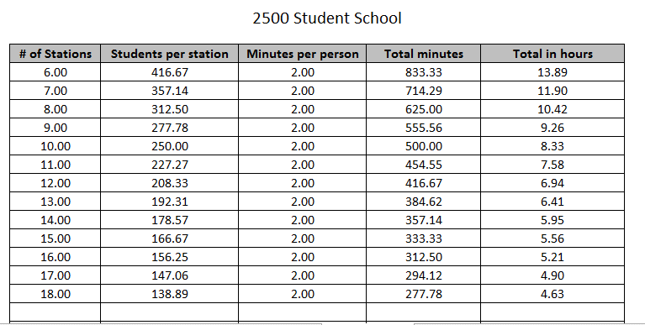

Based on the table above, if you only have 6 staff members to process a school with 2500 students, you can estimate it would take over 13 hours to accomplish reunification. By comparison, if you increase the number of staff members to 18, it will reduce the estimated time to just over 4 ½ hours. This is just an estimate and doesn’t account for all factors, but it does help to show the need for an appropriate number of staff members that are available (and trained) for reunification.

The primary role of the Request Gate personnel is to utilize the school’s student information database to ensure that the person requesting the release of the student is authorized to have them. For this role, consider who in your district has “all student” permissions for the school involved.
The process you use needs to fit your school and community, but the goal is to have complete accountability while maintaining a fast paced flow. Here is a visual example of what the flow of parents and paperwork may look like as part of an overall process.

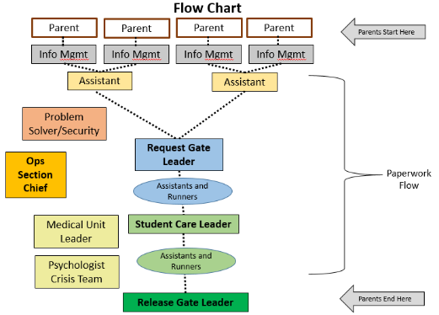
In this example, multiple staff members are serving parents and processing their completed Student Release Form. Once verified that the parent is authorized, the parents move to the Release Gate while the paperwork flows through the system. The Request Gate takes the paperwork and uses runners to deliver it to Student Care. Student Care would use assistants to locate the student and match them with the paperwork. Then, the student would be escorted to the Release Gate to be reunified with the waiting parent.
The goal is the orderly and managed return of student to their authorized parents/guardians, and in order to accomplish this, each step of the process must be written in advance.
The process should include:

- Request gate procedures.
- Student care procedures.
- Release gate procedures.
- The flow of parents and students.
- The paperwork is required at each step.

Hopefully, the number of times a school may have to do a parent/student reunification may be few and far between. This being said, staff members may not have much actual experience in conducting reunifications. Even if they receive annual training on the subject, remembering every detail of a reunification process may be unlikely. Consider conducting annual exercises in conjunction with “Just-In-Time” training for staff. Written job aides for their positions (checklists) will be very helpful and helps remind them of even the smallest of tasks. Examples of written job aides are included below.

Consider the following special circumstances when writing your plan:

- Adult Student: What is your plan for students who are age eighteen and want to sign themselves out? What is your policy when you are evacuating a campus but a student refuses to get on the bus?

- Parent Concerns: What will you do if a parent calls the school and demands their student be allowed to leave on their own? What if you can’t reach a parent or guardian, or the parent or guardian doesn’t show up at the reunification center to pick-up their child?

- Access or Functional Needs: Does your plan address the potential challenges faced by students, staff, and/or parents that may have access or functional needs.

- Language Barriers: Not every parent speaks English so translators may be required to effectively communicate. If your community has a high population of non-English speakers, you will want to consider the appropriate language speaking staff. If your community is almost entirely made up of English speakers, you may only need to have a translation service on contract that is available to assist by telephone, a Language Line, and/or picture cards.

- Patient Tracking: If students are or if staff is injured or deceased, does your plan include a process for working in conjunction with fire, EMS and/or hospitals? School staff may need to respond to area hospitals to help identify a child or provide the hospital with the child’s parent information.

- Mental Health: Recovery starts immediately after an incident occurs. Does your plan include a process for identifying mental health needs for students, staff, and possibly parents? Do you have a list of community resources available to refer parents to or work in conjunction with?

- Field Trips: How does your plan work for reunification on a field trip or other off-site events? Some of the same principles may apply, but it may not look the same as this plan.

- Extracurricular Events: Events that are outside of normal school hours – such as football games, basketball games, dances, band concerts, and so forth – create unique challenges. Often, the events are open to the public, so it is impossible for schools to know who is present. Schools may consider adding a section to the plan that outlines what their responsibilities are for student accountability if an emergency occurs during an extracurricular event. For example, a school may decide that it will account for the students that are officially part of the program or event but not for those that are attending as fans or the general public. If large numbers of people that are not students are involved, schools may have to work in conjunction with local authorities to set up a Family Reunification Center to help reunite loved ones. For details related to an established call center in Arizona, you can contact the Office of Emergency Preparedness at Arizona State University for more information.
Finally, there are an unlimited number of possible situations that could occur or complications you could face, and a reunification plan, no matter how complete, cannot account for all of them. For this reason, the plan should allow for some flexibility and outline the process for potential deviations. For example, it may state that the Operations Section Chief has the authority to deviate from the plan and make decisions based on the individual circumstances at hand.

Appendices

A - Student Release Form (page 26).
B – On-Site and Off-Site Evacuation Location (page 27).
C -- On-Site Areas for Your Campus and On-Site Reunification Locations (page 28).
D – Student Care Set Up and Request Gate (page 29).
E – Student Care (page 30).
F – Sample Letter for Parents/Guardians (page 31).
G – Sample Reunification Guide/Process Checklist (page 32).
H – Definitions (page 49).
I – Student Emergency Response Personal Safety Information Form – Elementary School (page 52).
J – Student Emergency Response Personal Safety Information Form – Middle School and High School (page 53).

Appendix A STUDENT RELEASE FORM
AUTORIZACIÓN PARA ENTREGAR A UN ESTUDIANTE A SUS PADRES O TUTORES LEGALES
Please Print Legibly – Complete a Separate Form for Each Student
Por favor scribe de manera legible – Llene un formulario aparte para cada estudiante

Student’s Name:_________________________________________ Grade:_____________
Nombre del estudiante: Grado:

Student’s Date of Birth:____________________ Student’s School ID#:_______________
Fecha de nacimiento del estudiante: Número de ID del estudiante:

School:______________________________Teacher:_______________________________
Escuela: Maestro:

Name of Person Requesting Student:___________________________________________
Nombre de la persona que vino para recoger al estudiante:

Requestor’s Driver’s License #: _____________________________ State: ____________
Número de la licencia de manejar: Estado:
(Photo ID is mandatory for student release. If you do not have a driver’s license, list another form of photo ID)
(Es obligatorio presentar identificación para recoger a un estudiante. Si usted no tiene una licencia de manejar, incluya otra forma de identificación que incluya una fotografía.)

Relationship to Student: _____________________________________________________
Parentesco con el estudiante:

DO NOT WRITE BELOW THIS LINE – NO ESCRIBA DEBAJO DE ESTA LÍNEA
Request Gate

Proof of Photo ID: (Yes) (No) Name Listed as Parent or Guardian: (Yes) (No)

Verified By:______________________ Name Listed as Emergency Contact: (Yes) (No)

Student Care (circle one)

Sent to Release Absent First Aid Missing

Comments: ________________________________________________________________

Release Gate

Proof of Photo ID: (Yes) (No) Released By:___________________________________
Requester Signature:
(Signature Indicates Release of Student) La firma indica la entrega del estudiante
Date: _____________________________ Time: ________________________________
Fecha: Hora:
White – Release Gate Yellow – Student Care Pink – Request Gate Goldenrod – Parent

Appendix B

On-Site Evacuation Locations:
Primary Assembly Area
Alternate Assembly Area
Areas of Refuge
Other relevant information

Off-Site Evacuation Locations:
Primary Assembly Area
Alternate Assembly Area
Areas of Refuge
Other relevant information

Appendix C

On-Site Areas for Your Campus
 | Primary |  | Alternate
On-Site School Command Post
Shelter-in-Place Areas
On-Site Reunification Locations
Student Care
Medical Area – First Aid
Area for special needs
Grief/counseling room
Request Gate
Release Gate
Parent parking and route to Request Gate
Employee parking and check-in desk
Other
Suggested Media Staging Area
Staging area for responding employees

Appendix D

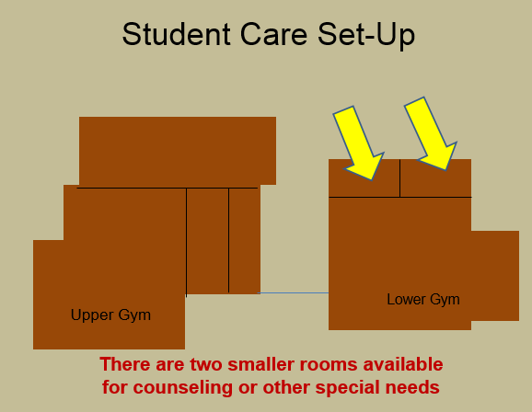

Appendix E
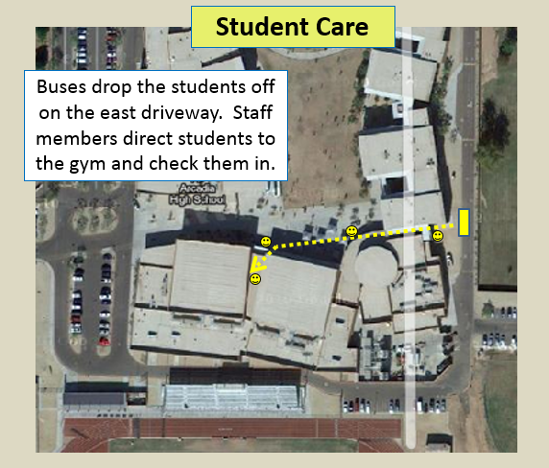

Appendix F

Sample Letter for Parents/Guardians

Parents and/or Guardians:

The SAMPLE School District has a detailed reunification process in place to help ensure the smooth return of all students to authorized parents or guardians. During this time, your student is being cared for by school personnel. We understand that this is a difficult and stressful time for everyone involved and appreciate your patience. This process is designed to ensure your student’s safety.

The reunification process is broken up into two separate stages: requesting your student and receiving your student.

The first step is to complete a Student Release Form at the Request Gate. School staff will verify that your student is only released to persons listed on the Student Profile Report which you complete at the start of every school year, including emergency contacts that you have authorized to assume temporary responsibility. You must complete or sign the duplicate form to indicate receipt of a student in a separate Student Release Form for each student you wish to pick up, and you must present your photo identification to the staff.

School personnel will confirm your identity and ensure you are authorized to pick up the students you have requested. Once confirmed, they will provide you with an authorization form and directions to the location of the Release Gate on campus where you will receive your student(s).

Please present the authorization form and photo identification to the school personnel at the Release Gate. Your student will be brought to that location.

As additional information becomes available regarding this situation, it will be posted to the school’s website.

Respectfully,

SAMPLE School District
Appendix G

Sample Reunification Guide/Process Checklist

Evacuating School:

- When a school has an emergency, follow the District’s emergency notification process and contact the Chief Security Officer or Security Program Supervisor or contact the person in your district who oversees emergency operations planning:

  - Chief Security Officer – (Insert telephone number).
  - Security Program Supervisor – (Insert telephone number).

- District resources will:

  - Contact transportation to arrange busses.
  - Contact the receiving school to have them begin the set up process.
  - Contact District employees to respond to the receiving school to assist.
  - Send an automated notification to parents once students have been relocated.

- All students and staff should be evacuated by school bus. Do not let people (including staff members) drive their personal vehicles:

  - If a student refuses to get on the bus to relocate, do not get into a physical confrontation with him/her unless they are a danger to themselves or others. Advise them they will receive discipline for not following the rules and note their name so we can contact parents when possible. Do not allow them access to their vehicle.

  - If the situation permits, students over the age of 18 can sign themselves out if requested, but they must complete the paperwork.

- When possible, send an administrator and/or the school’s Release Gate Leader on the first bus to the evacuation location.

- Send teachers and staff to supervise students on the bus. For accountability purposes, teachers should take attendance before leaving the classroom, when on the bus, and once seated in the off-site student assembly area. Report any unaccounted students to the Operations Section Chief and/or Incident Commander.

- Bring the daily attendance logs, student checkout logs, visitor logs, etc.

- Bring the school’s “green book” – back-up student profile information.

- The nurse should bring student medications; medical information; Individual Assistance Plans for students with disabilities, limited-English speaking students, and access and functional needs; etc.

- The school’s Incident Commander and Operations Section Chief must ensure that all students and staff have evacuated the campus.

Reunification School:

Once notified, the Reunification School should begin setting up their campus:

- The Incident Commander should activate the school’s Reunification Team.

- The Operations Section Chief should prepare the school for reunification:

  - Ensure ICS roles are filled and briefed. See instruction documents for assistance.
  - Locate additional staff members to help with the process.
  - Make certain all personnel “sign-in” and receive an assignment with instructions.
  - Locate the Reunification Kits that are stored at the off-site relocation center.
  - Set up Request Gate, Student Care, and Release Gate (consult plans, maps & diagrams).
  - Set up directional signs on campus and parking lots.
  - Coordinate with evacuating school as they arrive.

- District personnel will respond with additional equipment to include pop-up tents, signage, crowd control stanchions, traffic control barricades, etc.

Incident Command Vest Colors

Incident Command - White | PIO – Orange
Safety Officer – Black | Planning Chief – Blue
Operations Chief – Red | Logistics Chief – Lime Green
Release Team Leader – Red | Finance Chief – Dark Green
Request Team Leader – Red
Medical Team – Pink
Student Care – Red
Table Helpers - Lime
Runners - Orange
Student Information Management - Tan

Communications Department:

The Communications Department will be notified when parent/student reunification is necessary. Communications will assist in the following manner:

- Automated phone call to parents/guardians:

  - Determine if emergency contacts should be included in call.
  - Determine if text messaging should be used.
  - Determine if email messaging should be used.
  - The message should include:

    - Directions for where the Request Gate will be located on campus.
    - A reminder for parents to BRING THEIR PHOTO ID with them.

  - To avoid excess congestion at the relocation point, this message should not be sent until the students have arrived.

  - Record emergency messages on the emergency line.

- Communications can use other means of notification to include:

  - District and school websites.
  - Facebook and/or other social media sites.
  - Media resources.

Operations Section Chief:

The Operations Section Chief at the off-site relocation site that is handling the reunification has the overall responsibility for all activities of reunification. Through his or her leadership, the position oversees the operations of the Request Gate, Student Care, and Release Gate. The Operations Section Chief should not “do” the actual tasks but will provide direction and leadership to the other members of the incident command team.

The Operations Section Chief should ensure people are taking care of the following:

- If another school is used as the off-site relocation site, the campus is in a shelter-in-place or otherwise prepared to keep parents at bay.
- The Request Gate is set-up and prepared to receive parents.
- The Student Care is set-up and prepared to receive the evacuated students.
- The Release Gate is set-up and prepared to release students to their parents.
- All employees know their role and procedures.
- Supplies and equipment are available as needed.
- Personnel are rotated or given sufficient food, water, and breaks.
- Workers are mentally capable of handling assigned tasks and not being overcome by the circumstances.

One role of the Operations Section Chief is to solve problems that occur during reunification and make the final decision when there is a question if a student should be released.

Other Resources:

- Chief Security Officer and Security Program Supervisor.
- Student Information Management Team: Personnel to work at the Request, Release, and Student Care.
- Nutritional Services: Water/food for students and staff.
- Building Services:
  - Vehicles.
  - Personnel to assist where needed.
  - Emergency Equipment Trailer with:
    - Barricades, cones, and tape to control parent flow.
    - Pop-up shade tents.
    - Fans or portable coolers.

Request Gate Set-Up:

- Consult the map for the pre-identified location of the Request Gate.

- Locate the site’s Parent/Student Reunification Supply Kit, which includes A-Z file sorter, clipboards, pens, power strips, extension cords, supply of Student Release Forms, and Letter for Waiting Parents.

- Secure the rest of the campus to ensure parents can’t enter.

- There could be many employees responding from the District to assist at this location. Pre-identify tables and chairs to support this large number. Set up the tables to help channel responding parents and provide a workspace for school staff. Use crowd control stanchions to guide the line of waiting parents.

- It may be helpful to place some tables out by the line of waiting parents to assist with completing the Student Release Form. Include the Letter for Waiting Parents.

- Consider having available a sound system/megaphone.

- Set up signage directing parents to the Request Gate. This sign says, “Station 1 – start here”.

- Locate a power supply for computers and secure cords with tape to avoid trip hazards.

- Identify personnel. In addition to the site ICS Request Gate Leader, assign the following personnel from either the hosting site, district personnel, and/or evacuating site:

  - Ideally, there will be a minimum of ten (10) district level personnel responding, possibly up to twenty (20). Note: If for some reason the Student Information Management team is not able to respond to your school, you will need to conduct this process with site based staffing.

  - Two assistants for the Request Gate Leader to use to help coordinate the paperwork flow.

  - Somebody to help solve problems and deal with angry parents (security or administrator level preferred). If there is a problem with a parent, the staff member that is helping them will hold up a yellow sign asking for assistance.

  - Three or four staff members to help greet the parents, hand out clipboards, keep them in line, etc.

  - Runners to help shuttle paperwork and escort students (may use district level staffing or possibly high school students if appropriate).

- Consider using counselors, front office administrative staff, available teachers, para-professionals, equipment managers, district personnel, etc.

- Conduct “just-in-time” training (a briefing) with staff to explain the process and their role.

Request Gate Process:

- Under the direction of the Operations Section Chief, the Request Gate Leader is responsible for the overall coordination of Request Gate information and operations. The Request Gate Leader should assign and lead personnel to fulfill the necessary roles to carry out this process.

- When parents arrive, school staff will give them a clipboard and pen to complete the top section of the four-part Student Release Form. Hand parents a copy of the Letter to Waiting Parents. Direct parents to have their ID ready for when they reach the tables.

- If a parent is requesting multiple students, the parent must complete a separate form for each student.

- The parent gives the completed form(s) and their Identification to Student Information Management personnel working the tables.

- When a parent submits multiple forms, Student Information Management should write “1 of #” on the top of the form to indicate how many are together.

- Student Information Management verifies the parent’s ID and looks up the student’s name in the student information profile to verify the requestor is either a parent/guardian or listed as an emergency contact. The staff member circles “yes” for proof of ID, indicates if the requestor is listed as a parent/guardian or emergency contact, and initials under “verified by”.

- If the requesting person does not have identification, the student cannot be released unless a school/district employee personally recognizes the person and can verify they are who they say they are. In this case, that staff member should circle “no” for proof of ID and clearly print and sign under “verified by”. The requestor must still be authorized on the student profile.

- If the requesting person is not listed on the student’s information profile as either a parent/guardian or emergency contact, DO NOT release the student. Explain that they are not listed as an authorized person. If there are any conflicts, hold the yellow help needed sign in the air and ask the person to step aside to the staff member/security responsible for problem solving. Keep the Student Release Form.

- Upon release, Student Information Management checks the student off on their A-Z Name List (or blank student release log if the lists have not arrived yet) and files the pink copy of the form in the A-Z sorter.

- Student Information Management gives the parent the bottom (goldenrod) copy of the form as well as directions to the Release Gate. Explain they will need to use the goldenrod copy as their “ticket” to enter and retrieve their student. Explain they will need to show their ID again at the Release Gate.

- Student Information Management gives the white and yellow copies to the Request Gate Leader.

- Student Information Management keeps the pink copy of the form.

- The Request Gate Leader collects the white and yellow copies of the Student Release Forms. Once enough forms are collected to ensure efficiency, they send runners over to Student Care with both the white and yellow copies of the form.

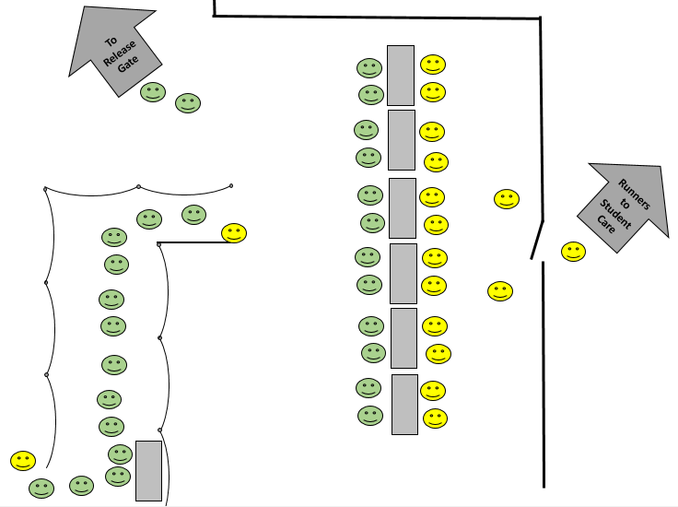
Student Information Management Team:
When activated, call employees from Student Information Management team and direct them where to respond.
- The closest team member should start printing at least twenty (20) copies of the A-Z Name List for that school. If their laptop has not been updated recently with a current version of this list, they should update their C-drive data prior to printing the list.

- Gather the Reunification Supply Kit, laptops, and hotspots while the lists are printing.

- Respond safely to the school and park in the pre-designated location. Consult your maps of campus to determine the location of the Request Gate. Each event may be different and deviate slightly from the general plan.

- Provide Student Care with the “A-Z Master Name List” as soon as possible.

- Upon arrival, contact the school’s Operation Chief or Request Gate Leader to determine if reunification has already begun. As needed, set up the area and review the instruction sheets for Request Gate, Student Care, and Release Gate.

- Manage and guide your staff. Most of the team will work at the Request Gate to process parent information, but you may direct staff to other areas are needed.

- Review the checklist below for information.

Student Information Management – Request Gate Process:
Verify form is complete:
- Complete Section Request Gate:

  - Proof of identification (ID) – Y/N.
  - Name the individual(s) listed as Parent/Guardian – Y/N (verify in the student information profile or on hard copy of profile).
  - Name the individual(s) listed as Emergency Contact – Y/N.
  - Verified By: If NO on ID, list the staff person who verified. If YES on ID, please sign or initial name.
  - If the parent has multiple students, write 1 of # on top of form.

- Goldenrod Copy (bottom page) – Give to the parent with directions to the Release Gate.

- Pink Copy (second from bottom) – Keep at the Request Gate.

- White and Yellow (top two sheets) – Give to the Runner.
If person requesting student is NOT listed as a parent or emergency contact, keep all copies and write at the top “DENIED, NOT LISTED” and file with Pink copies at the Request Gate.

Student Care Set-up:
- Student Care locations have been pre-identified at the off-site relocation centers. Generally, they are located in the main and auxiliary gyms. Smaller rooms may be used to house special needs students, such as those requiring quiet space, and act as counseling rooms as necessary.

- Auditoriums may be used especially if the evacuating school is small enough to fit in the auditorium. Student Care will work with the Medical Team Leader and Mental Health Crisis Response Team.

- When possible, account for students as they arrive at and enter the Student Care area. Have teachers maintain a list of student names.

- Use a seating chart that separates students inside the off-site relocation center. This can be based on homeroom teacher, grade level, etc. Use whatever system is most convenient based on the set-up of that school. Create signs to direct students.

- Place staff near exterior doors to ensure accountability of the student population. Over time, students may try to wander away. Additional personnel may be necessary to escort students to restrooms, get a drink of water, etc.

- When possible, find appropriate ways to entertain students based on their age group. Consider playing music, watching movies, playing games, etc. Provide continual updates to students in order to keep them informed (as appropriate based on age).

- Locate the following supplies:

  - At least three tables and three chairs (set-up diagram below).
  - Computer within internet access (information profile) when available.
  - Locate a power supply for computers and use a loud speaker and/or megaphone system to make announcements. Secure cords with tape to avoid trip hazards.
  - One A to Z sorter to hold paperwork, highlighter, pens, tape (stored in kit)
  - Master A-Z Name List (printed by Student Information Management) – tape this to one of the tables so all names are visible in alphabetical order.
  - Evacuating school’s attendance logs and student/visitor sign-out sheets.
  - School radio and phone access when available.

- Identify personnel:

  - In addition to the site ICS Student Care Team Leader, assign the following personnel from either the hosting site, district personnel, or evacuating site to assist the Student Care Leader:

    - At least four assistants (preferably five or six to allow for breaks).
    - Several runners (may use district level employees or high school students if appropriate).

  - Teachers are responsible for supervising their students while in Student Care.

Student Care Process:

- Student Care is responsible for keeping the “Master List” of students that are being released. This position is the primary location for accounting for all students.

- The Release Gate will send runners with the white and yellow copies of the Student Release Form to Student Care indicating a student(s) has been approved for release.

- Once notified, a Student Care assistant and/or runner will locate the student and get him/her prepared for release. The student should bring all of his/her belongings.

- Student Care must receive both the white and yellow copies of the Student Release Form before sending the student over to the Release Gate.

- When a student is located and being sent to the Release Gate:

  - Student Care will “cross-out” the student’s name on the A-Z Master Name List (and/or Green Book if the master list is not there yet).
  - Student Care circles “sent to release” on the Student Release Form and keeps/files the yellow copy in their accordion file folder.
  - Student Care sends the student along with the white copy of the Student Release Form to the Release Gate (escorted by a runner).

- If a student is not located:

  - Student Care should have a computer to access the student information profile to verify attendance.
  - Student Care will check to see if the student was marked absent, was signed out during the day, is receiving medical care, ask the teacher, etc.
  - If the student is determined to be missing or otherwise not accounted for, they highlight the student’s name on the A-Z Master Name List.
  - Student Care marks the Student Release Form appropriately (absent, first aid or missing) and keeps/files the yellow copy in their accordion file folder:
    - Absent - the student was never in school that day (verified or unverified)
    - Missing – the student was present at school, but their location is not known at this time
    - First Aid – the student’s location is known and is receiving medical care
  - If the student is missing, Student Care should notify the Operations Section Chief and Release Gate Leader that a student has not been accounted for.
  - Student Care sends the white copy of the Student Release Form to the Release Gate in order to notify the parent.
  - The parent should be moved away from the crowd and brought to a more private location. When available, use a psychologist and/or law enforcement to assist in this notification process.

Review specific job assignments and diagram below:

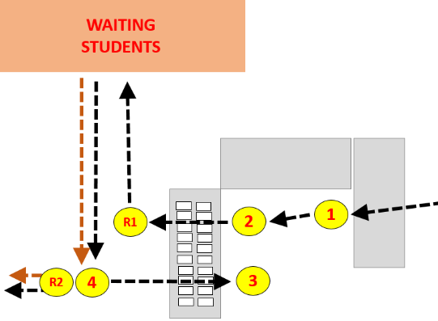

White and yellow copy of the form comes from the Request Gate

Runner takes student(s) and white copy of form to Release Gate

Position #1: Receives white and yellow copies of Student Release Form from the Request Gate and gives them Position #2. Answers questions and ensures other people do not bother Position #2 and #3 so they can focus on their role.

Position #2: Checks names on Student Release Form(s) against the A-Z Master Name List taped on the table. If the student is listed (and not crossed out), they put a mark (a dot) next to that name. The position hands both the white and yellow copy to a Runner to find the student(s).

Runner #1: Takes the white and yellow form(s) and finds the student(s). Return the student(s) and paperwork to Position #4.

Position #4: Have the students wait in a holding area. They mark the paperwork appropriately, gives the yellow copy to Position #3, and provides the student and accompanying white copy to Runner #2 to escort them to the Release Gate.

Position #3: Takes the yellow copy and looks at how it is marked. If the student was found and sent to Release Gate, they cross out that student’s name on the A-Z Master Name List. File the yellow form.

Runner #2: Takes the student(s) and accompanying white copy of the form to the Release Gate.

Medical Set-Up:
- Medical works closely with Student Care.
- Student Care locations have been pre-identified at the off-site relocation centers. Generally, they are located in the main and auxiliary gyms. Smaller rooms can be used to house special needs students and act as counseling rooms as necessary.
- Auditoriums may be used as well, especially if the evacuating school is small enough to fit in the auditorium.
- Medical should bring whatever first aid supplies available to assist when needed.

Medical Process: The Medical Team works in conjunction with Student Care to help provide for the needs of the students. Medical should consider student concerns such as:
  - Daily medication needs of students.
  - Care for students that are medically fragile.
  - Provision of minor first aid as appropriate.
  - Consideration of the student’s food and water needs.

Release Gate Set-Up:

- Consult the map for the pre-identified location of the Release Gate.
- Locate at least three tables and four chairs.
- Ensure there is signage directing parents to the Release Gate. The signs say, “Station 2”
- The Release Gate requires one of the A-Z sorters, clipboards, pens, and a school radio
- Identify personnel. In addition to the site ICS Release Gate Team Leader, assign the following personnel from either the hosting and/or evacuating site:
- Three or four assistants.
- Runners (share those running between Student Care and Release Gate).
- Access to psychologists, counselors, security staff, and law enforcement.

Release Gate Process
Parents coming from Request Gate
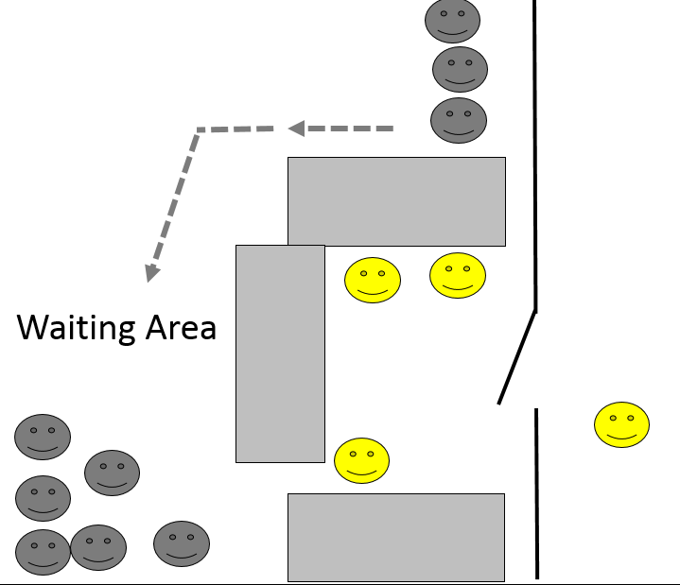
Students coming from Student Care
Release Gate Process:

- Parents must first check in at the Request Gate before coming to the Release Gate. The Parent must produce the goldenrod copy of the Student Release Form as their “ticket” to get their student. If a parent does not have this, send them to the Request Gate.

- Each student will require a separate goldenrod form.

- If a student was located in Student Care:

  - The student will be escorted to the Release Gate along with the white copy of the Student Release Form.

  - Release Gate staff will look at the parent’s identification just to confirm they are the same person listed on the form. If the parent doesn’t have ID, the form should already indicate that a staff member at the Request Gate circled “no” and signed as verification.

  - If the parent doesn’t have ID and the “no” is not circled/signed, notify the staff member/security responsible for problem solving. Do not release the student until this is resolved.

  - The Release Gate has the parent sign the white copy of the Student Release Form and files it in an A-Z sorter.

  - The parent keeps the goldenrod copy of the Student Release Form.

  - The student is turned over to the parent.

- If the student was not located in Student Care:

  - A runner will send the white copy of the Student Release Form to the Release Gate, but there will be no student. The form should be marked:

    - Absent – the student was never in school that day (verified or unverified).
    - Missing – the student was present at school, but their location is not known at this time.
    - First Aid – the student’s location is known and is receiving medical treatment.

  - The Release Gate staff will ask for assistance from psychologists, administration, security, or law enforcement to notify the parent as appropriate.

  - Release Gate will file the white copy of the Student Release Form in a separate folder for missing, absent, medical, or other special circumstances.

Mental Health Crisis Response Team:

The Mental Health Crisis Response Team is a group of employees who come together at the request of the Executive Director of Support Services in order to help maintain the best possible learning environment while dealing appropriately with tragedies which may arise.
During parent/student reunification, the team should be assigned to the Operations Section Chief for the following roles:

- If students have been transported, send staff to area hospitals to be the district liaison for hospital staff and families.

- Consider riding the busses as they evacuate a school – this allows for crisis personnel to quickly observe student reactions and plan accordingly.

- Staff 3 separate areas at reunification:
  - Student Care – helping students and staff.
  - Request Gate – helping parents (as needed).
  - Release Gate – helping students going back to parents (as needed).

- Work with Police/Fire crisis intervention teams. They will do death notifications, but they may need school personnel assistance with student and family information.

Team members can refer to the Mental Health Crisis Response Team protocols for further information.

In the event additional mental or behavioral health assets are needed, contact the regional mental health authority. Have a relationship already established with the contact and test the ability to contact the authority during an exercise.

Attachment H

Definitions

Reunification | The process of reuniting family members with their missing or deceased loved one.
Emergency Call Center | Following a mass casualty or mass fatality incident, this designated space is activated as a communications hub to collect information from families and friends of possible victims (integrates Medical Examiner/Coroner interviews); to direct families and friends to appropriate Hospital Reception Sites, Family Reunification Centers, or Family Assistance Centers for reunification and assistance; and to direct other callers to appropriate recipients, such as Public Information Officers.
Family Assistance Center  (Long-Term) | Following a large mass casualty or mass fatality incident, this designated county or state space is established as a centralized location for families (and friends) to gather, receive information about the victims and grieve, protect families from the media and curiosity seekers, facilitate information sharing to support family reunification (e.g., direct families to Hospital Reception Sites if victims are known to have been transported to the location), and provide death notification when patients die and identity is known. This Center is long-term and may target delivery of a range of services and/or may focus on families and friends of missing or deceased victims.
School Reunification Center (Short-Term) | In the immediate hours after an incident, this designated space is established as a centralized location for students, employees, families (and friends) to gather, receive information about the victims and grieve, protect families from the media and curiosity seekers, facilitate information sharing to support family reunification (e.g., direct families to Hospital Reception Sites if victims are known to have been transported to the location), and provide death notification when patients die and identity is known. This Center is short-term and may be replaced by a Family Reunification Center, Family Assistance Center, or shelter in the event a municipality, County, or State or other jurisdiction deems this to be necessary.
Family Reunification Center (Short-Term) | In the immediate hours after an incident, if an incident is large and exhausts the capacity of a school or school district, this designated community space is established as a centralized location for students, employees, families (and friends) to gather, receive information about the victims and grieve, protect families from the media and curiosity seekers, facilitate information sharing to support family reunification (e.g., direct families to Hospital Reception Sites if victims are known to have been transported to the location), and provide death notification when patients die and identity is known. This Center is short-term and may be replaced by Family Assistance Center or shelter in the event a municipality, County, or State or other jurisdiction deems this to be necessary.
Hospital Reception Site | A hospital space designated to provide a private and secure place for families to gather, receive information about the patients and grieve, protect families from the media and curiosity seekers, facilitate information sharing with other hospitals and partners to support family reunification (e.g., direct families to the right location if victims are missing), and provide death notification when patients die and identity is known.
Family | Any individuals that consider themselves to be a part of the victim’s family, even if there is not a legal familial relationship. This could include friends, partners, caretakers and loved ones that have defined themselves or are indicated by other family members to be “family”.
Immediate Family | A defined group of relations, used in rules or laws to determine which members of a person's family are affected by those rules. It normally includes a person's parents, spouses, siblings and children.
Custodial Parent | The parent, also considered the primary care parent, a child resides with full time. Most custodial parents have been awarded physical custody of a child by a court of law.
Legal Guardian | A person or entity who has been granted the legal authority (and the corresponding duty) to care for the personal and property interests of another person, called a ward.
Legal Next of Kin | The nearest blood relatives of a person who has died, including the surviving spouse.
Separated Children | Children who have been separated from both parents or from their previous legal or customary primary caregiver, but not necessarily from other relatives. These may, therefore, include children accompanied by other adult family members.
Unaccompanied Minors | Children who have been separated from both parents, legal guardians, and other relatives and are not being cared for by an adult who, by law or custom, is responsible for doing so (18 or under).

Attachment I - CONFIDENTIAL  Student Emergency Response  Personal Safety Information Form | Place Student’s Picture Here  Elementary School

Name of Student: | School: |  | Grade:
Site Special Needs Safety Coordinator: |  | Site Principal:
Completed by: |  | Date completed:

Please check the box next to the condition that identifies the student’s need for evacuation assistance. Check all boxes that apply:
- Communication or Speech-Related Disability: |  |  |  |  |  | Non-verbal |  |  | Non-English speaking |  | Uses sign language
- The student is mobility impaired and uses:
 | Wheelchair |  | Walker |  | Body Brace |  | Other
- The student has a vision/hearing impairment:
 | Legally blind (Do not check box when the sight is resolved by wearing corrective lenses)
 | Hearing impaired
 | Uses assistive equipment/technology (Please specify)
- The student has the following condition(s):
 | Autism | Seizure |  | Intellectual Disability |  |  |  | Severe Allergy |  | Asthma |  | Diabetes
 | Emotional/Psychological Disorder: |  |  |  |  |  |  |  | Other Health Condition:
Medication(s) Taken:

Medication |  | Dosage | Time(s) | Taken At Home |  | Taken At School
1. |  |  |  | Yes | No | Yes | No
2. |  |  |  | Yes | No | Yes | No
3. |  |  |  | Yes | No | Yes | No

Other equipment required (if applicable):
Type of Evacuation Equipment (if applicable):
Location of Evacuation Equipment (if applicable):
Special Instructions:

This plan will be revised as necessary to address the student’s schedule changes.
Time of Day | Room # | Teacher | Assigned Personnel for Evacuation
 |  |  | Primary | Alternate
Before School Program
After School Program

I acknowledge, with my signature below, that the information on this plan concerning my child is accurate and have been provided the opportunity to discuss with district personnel any concerns that I may have concerning the safety of my child in the event of an emergency. I also permit the release of this document to any and all persons assisting during an emergency, including district staff, volunteers, and emergency responders. I understand that I have the right to revoke this authorization, in writing, at any time.

PRINT Parent Name: | Parent Signature:
 | Date:

Important Note: Use of this form should be approved by district senior leadership and district legal counsel.
Attachment J - CONFIDENTIAL  Student Emergency Response  Personal Safety Information Form | Middle School/High School  Place Student’s Picture Here

Name of Student: | School: |  | Grade:
Site Special Needs Safety Coordinator: |  | Site Principal:
Completed by: |  | Date completed:

Please check the box next to the condition that identifies the student’s need for evacuation assistance. Check all boxes that apply:
- Communication or Speech-Related Disability: |  |  |  |  |  | Non-verbal |  |  | Non-English speaking |  | Uses sign language
- The student is mobility impaired and uses:
 | Wheelchair |  | Walker |  | Body Brace |  | Other
- The student has a vision/hearing impairment:
 | Legally blind (Do not check box when the sight is resolved by wearing corrective lenses)
 | Hearing impaired
 | Uses assistive equipment/technology (Please specify)
- The student has the following condition(s):
 | Autism | Seizure |  | Intellectual Disability |  |  |  | Severe Allergy |  | Asthma |  | Diabetes
 | Emotional/Psychological Disorder: |  |  |  |  |  |  |  | Other Health Condition:
Medication(s) Taken:

Medication |  | Dosage | Time(s) | Taken At Home |  | Taken At School
1. |  |  |  | Yes | No | Yes | No
2. |  |  |  | Yes | No | Yes | No
3. |  |  |  | Yes | No | Yes | No

Other equipment required (if applicable):
Type of Evacuation Equipment (if applicable):
Location of Evacuation Equipment (if applicable):
Special Instructions:
This plan will be revised as necessary to address the student’s schedule changes.
Period | Room # | Teacher | Assigned Personnel for Evacuation
 |  |  | Primary | Alternate
1
2
3
4
Lunch
5
6
7
8

I acknowledge, with my signature below, that the information on this plan concerning my child is accurate and have been provided the opportunity to discuss with district personnel any concerns that I may have concerning the safety of my child in the event of an emergency. I also permit the release of this document to any and all persons assisting during an emergency, including district staff, volunteers, and emergency responders. I understand that I have the right to revoke this authorization, in writing, at any time.

PRINT Parent Name: | Parent Signature:
 | Date:

Important Note: Use of this form should be approved by district senior leadership and district legal counsel.

